Machine Learning Classifier for Mobile Malware Detection

Dissertation

Student Name: Harjinder

Table of Contents
Chapter # 1 Introduction 6
1.2. Problem Statement 7
1.3. Research Gap 8
1.4. Aims & Objective of Thesis 9
1.5. Challenges & Contribution 9
1.6. Machine learning challenges 9
2. Literature Review 11
2.1 Related Work 11
2.2. Distance Measure in K nearest Neighbor 17
2.3 Argumentative attacks on Mobile Malware Detection 18
2.4 Machine learning algorithm 18
2.5 Machine learning classification malware detection using Opcode 19
2.6 Understanding of Mobile Malware 20
2.7 Reverse Engineering techniques 21
2.8 Security feature in Android 22
2.9 How to Secure Android Device 22
2.10 Support Vector Machine & Random Forest Classifier 23
2.11 Decision Tree Classifier 24
2.12 Summary of Literature Review 25
Chapter # 3 Methodology 26
3.1 Introduction 26
3.2 Research Philosophy 26
3.3 Data Interpretation 27
3.4 Research Strategy 28
3.5 Data collection Method 28
Primary Dataset: 28
Secondary Dataset: 28
3.6 Data Analysis Method 29
3.7 Research Consequences 29
3.8 Research Sources 30
3.9 Ethical Concern 30
Chapter # 4 Results & Analysis 32
4.1 Support Vector Machine Classifier, Random Forest Classifier, Decision Tree Classifier 32
4.2 Programing Task 33
Importing python libraries 33
Loading dataset 33
4.3 Data Cleaning 34
4.4 Removing Null Values and Fixing data types for column 35
4.5 Convert text columns to integer data type 35
4.6 Stripping white spaces in columns 36
4.7 Top 10 permission rating Bar graph 37
4.8 Data Visualization 37
4.9 Bar Plot 38
4.10 Distribution plot of Rating of Malicious App 38
4.11 Distribution of rating of Benign App 39
4.12 Malicious Distribution of Malware App 39
4.13 Android Version Malicious Ratio 40
4.14 Distribution days of publish Histogram 40
4.15 Machine learning python libraries 41
4.16 Removing unnecessary columns from the dataset 42
4.17 StandardScaler feature 42
4.18 Training and testing features Model development 43
4.19 Non Normalized Confusion Matrix 43
4.20 Non Normalized Confusion Matrix 44
4.21 Model Tuning 47
4.22 Non Normalized Confusion Matrix Plot 48
4.23 Outcome 49
Confusion matrix without normalization 49
4.24 Optimal classifier configuration 50
4.25 Decision Tree classifier result 50
4.26 Artificial Neural Network with SVM 52
4.28 Importing APK libraries 53
4.29 Importing System, OS Statistical 54
4.30 Print Predicted validated Data value 54
4.31 Support vector machine with Grid search to tune model 55
EPOCH Call Kernel 55
4.32 Classification Report 56
Prediction 56
4.33 Android Permission Data 57
4.34 Multilayer Perceptron (Artificial neural network) 57
Sequential RELU Metrics 58
Android API APK 59
Android malware prediction accuracy 59
Android malware prediction accuracy 60
4.35 Analysis 60
4.36 Genetics Algorithm 62
4.37 Programing Task 62
Importing Python Libraries in Notebook 62
Importing dataset 63
SVC Mean Squared ERROR 63
Genetic Selector 63
Score Generation 64
Mean square ERROR after feature selection 65
Import Pickle library 65
Trainings & Testing dataset 65
ANN Sequential 65
EPOCH 66
Andro Guard 67
SVC 67
Classification Report 67
4.38 Results & Analysis 68
Chapter # 5 Discussion & Conclusion 72
Comparison 74
Research Achievement 74
5.1 Research Invention 74
5.2 Mobile Malware Discovery 75
5.3 Research Outcome 76
6.References 78
Appendices 85
About the APP on Google Play store 85
Ratings & Reviews on Google Play store 85
Editor Choice APP 85

Chapter # 1 Introduction

Machine learning model used to predict detect any vulnerability attack on mobile device, (Narudin, F.A., Feizollah, 2016) android phone various malware has been detected due to running of unsafe application. Using the deep learning mode application in the android phone which essentially required to safe inside and outside mobile application. Custom neural network deep learning algorithm classify vulnerability and malware attack and it produces the high accuracy, deep learning model scans 1000 of running applications in second and if any malware detected, it fix it automatically. (Mercaldo, F. Santone, A., 2020) deep learning model learns itself the subtle cues that malware stand out from safe applications, this removes human bias and preconceptions from the decision process, the networks can find pattern that are not obvious to human analysts, which makes harder for malicious apps to evade detection, for each app, the evidence from the machine code can be combined with additional information such as the permissions required by the app, its API calls, and its manifest to reach and even more accurate to reach resilient decision. Machine learning neural network can stand alone on the end user’s mobile device so it does not need an internet network connection to work, deep learning model approach refine and classify the applications more efficiently to identify and predict the malware from the applications, malware could be able to harm the user applications as well hardware storage system, and its robust against the methods used to obscure and hide malicious code in the form of encryption. Machine learning Technology is platform in which malware virus can be detected and fixed on scanning the android phone network. Deep learning model has been working on prototype methods because various industrial IOT applications essentially improved the security and data protection. It enables enterprise user secure IOT devices across the network and its able to scan the individual mobile application as well, finally cloud application also scan during the uploading and downloading from the cloud computing. Android phone users which has total of 72.2% of market share in world mobile survey in recent research 2020. Hackers wants to attack android phone to steal and capture important data & information from the cell phone, with various method such as credential theft, surveillance, malicious advertising, so machine learning algorithm effectively works well to detect and identify the threats and malware attack in the mobile phone. This research going to provides the brief & systematic approach to detect and defined the android mobile user malware attack system. (Liu, Y., 2020) experiences landing of machine learning technique onto the market scale using the mobile malware detection & prevention. The better understanding of mobile android phone implementing by the various machine learning techniques & advanced machine learning algorithm. Failure of android devices due to instability of android phone, the mobile user increasing day by day due to emerging technology of software application. In previous research the research gap exist due to the insecure mobile applications version and insecure third party applications and non-reliable applications which does not provides the security features. The implementation of T-market for over one year using single commodity server to vet of 10K apps every day. The evaluation result presented in this research archive the overall precision call score of 98% accuracy by implementing advance machine learning methods such as genetic algorithm, support vector machine, naïve bays & decision tree classifier technique. By selecting the feature selection of machine learning of training and testing the dataset, the feature selection is main component of removing malware from the android phone and use of machine learning techniques to fix them by scanning the mobile applications in real time, Google provides the best state of the art security feature to the android phone because of advance machine learning methods which was essentially used by the operating to system to scan the android applications. The scanning applications has been detected & predicted which essentially helpful for the user to secure the android applications. Android user used various third party application which was not secured due to less security features and the security feature does not support third party applications so the previous research address them to fix the android malware by implementing the machine learning algorithm to predict and prevent the machine learning algorithms. The machine learning prediction technique briefly describe in literature review section and methods chapter discussed the research methods in which the problem has been solved.

1.2. Problem Statement
The research problem is highlight the mobile malware, which needs to remove and fixed from the android phone. Various machine learning methods and advance programming techniques has been used in previous research, this research going to present and merge them the existing and new machine learning technique, literature review section solved the android malware problem by addressing the research question. In chapter 4 the result & analysis part combine the previous outcomes and new advance improved machine learning technique has been addressed briefly. The common android phone problem exist in previous mobile android version which was known as malware as follows:
- Adware
- Backdoor
- Ransomware
- Riskware
- Scareware
- Spyware
- Trojan
- Trojan-sms
- Trojan spy
- PUA potentially unwanted application
- File infector
Most common type of malware is known as adware which disturbs the user by sending unwanted spam advertisements, which might be attracted the user and redirect them to capture sensitive information from mobile phone. The malware detection &prevention issues has been resolved in chapter 2 and chapter 4 by using the advance machine learning methods. Previous releases of android version contains security issues & malware issues, but the current research presented the state of the art security problem which ask security permission from the user to access any mobile app from other user, if user ask for any app to access from other user app android grant the permission if user grant them to executes. Android phone is commonly used by user with with market shares of 86%, because android phone choice of every community including student and business men.

1.3. Research Gap

Negativity & issues has been found in previous android operating system releases, various security issues has been exist in android version 4, 5 & 6. Google updated the security features in android 11 and 12 version. It is noted that in old android version there is lack of screen touch issues found and Google map navigation issue exist. Google search engine not displaying on android screen in previous android releases. Research gap exist from 2011-2017 due to instability of android operating system, but after release of updated android version 10 and 11 the security features and malware scanning feature has been updated by Google. This research address the research gap from 2011 to 2017 in literature review section, negativity and common problems & security issues has been address in literature review chapter and chapter 3 address the research methods by using the advance machine learning technique.

1.4. Aims & Objective of Thesis
Aim of this research to produce machine learning algorithm for android mobile operating system to detect malware in the operating system. By implementing bays network and random forest classifier algorithm which produced the highest accuracy rates of malware detection.
Objectives of this research is to plan latest machine learning algorithm which is based on malware attack detection method. This research objectives is going to address the previous android phone negativity and latest android phone positive points. The negativity issues has been addressed in literature review section, and solution has been addressed from the Google android latest version with enhance security feature.

1.5. Challenges & Contribution

(Sahib, N.M., 2021) mobile phone users increasing on daily basis due to increase demands of online communication and online business, various educational institutes planned online lecture session for distance learning and training. Challenge remain exist due to various vulnerable attack happened on mobile phone devices, android phone security feature updated but the challenge and issue remain questionable to get the secret info from the mobile device, mobile apps provides the great convenient feature to user for instant access of weather update, sports update and ongoing communication over the internet by sending instant messaging.

1.6. Machine learning challenges

Machine learning programming facing the following challenges as follows
- Deprived superiority of data
- Underfitting of training data
- Overfitting of training data
- Absence of training data by using the differ sample size
- Immaterial feature selection from dataset
- Trash in and trash out info
Non representative of training dataset, the common issues mainly deal by the machine learning contains to select & predict the irrelevant machine learning dataset. Select the more advanced model one and more parameter selection. Reducing the number of training dataset attributes from the given dataset. The major issue in machine by selecting the dataset and cleaning the dataset, because various data scientist, the solution has been provided by the Kaggle and machine learning UCI repository.

2. Literature Review
Literature studies is part of previous research publications research finding which was formulated on mobile malware machine learning classification method. In literature the finding describes the methods and analysis including research aims & objectives. The problem statement is in view of android phone malware system to scan & predict the malware from the android device.

2.1 Related Work

Machine learning classifier for android malware detection (M. Z. Mas'ud, S. Abdollah 2014) primarily focused on mobile application which needs security & privacy to secure personal data from unknown hacking attack. With huge number of android user various mobile user used various application for different purposes, Through operator remain nowadays competent to consumes the use of mobile applications for different purpose such as web browsing, online banking, payment and order taking purposes and various businessmen used for meetings and financial tasks and social networking with MMS. Different credential and secured applications needs security and privacy concerned, similar security solutions exists which was provided by the Google operating system, hence there is need to develop the mobile malware detection tools which provides the security to android phone user. Mobile CPU is differ from desktop, it little bit better comparatively to perform the query on demand which enables the user to connect millions of applications in real time, the best machine learning classifier, the combination of feature selection classifier, in this research five machine learning classifier has been proposed prior to do the particular analysis, calculation expected on positive false rate and positive false negative rate to capture the accuracy (Wang, L. Yang, B., 2018) machine learning based malware detection using highly imbalanced network traffic, due to increasing number of android malicious app which brings the network traffic to imbalanced the situation to combine the network capture classification analysis and mobile malware classification so the technique is used to enables the user to scan the mobile phone to detect malware from the android operating system. However the support vector machine classifier enable the user to imbalanced the malware from device using the cost sensitive technique with C4.5 cost sensitive method. The classification algorithm degrades significantly including data gravitational based classified the simplex gravitational data imbalanced classification technique, the simplex gravitational data models classified the prototype system which provides user substantial autonomy (Choi, M.J., 2013) analysis of android malware detection performance using machine learning classification method, since the mobile device support various user applications , personal information & private message has been captured due to unstable version of android operating system in 2013, since the mobile contains confidential information including sensitive data such as bank account details, emails data and personal messages in the mobile inbox. Attacker extends the attacker range not only in the desktop computing also in mobile phone network, previous studies of android malware detection present that due to instable version of android operating system needs to improve internal security structure system on the entire android telephone network, so in previous version of android phone machine learning classifier has been deployed but the detection accuracy was very low, mobile malware detection system generated the android application app scanner to do the scanning system and perform various scanning task. Preceding educations present that the mobile android to perform the machine learning classification technique to detect the various malware through collecting analyzing event and system within the android device, the understanding of android architecture with malware characteristics generate resource consumptions overhead of android device including low ratio of malware detection (White, J., 2013) applying the machine learning technique with dynamic android detection at scale the sensitive nature of android phone needs more security & user preferences the increasing concerned of smart phone malware, machine learning classifier current method of detecting malicious applications over the smart phone device, this research present evaluation of number of machine learning classifier using dataset containing thousands of real time applications including offline and online applications, since the stream framework of developed large scale validation of mobile malware detection including machine learning classification technique (Vaglini, G., 2020) model checking and machine learning technique for humming bad malware detection and extenuation, since the android operating system created with various programing technique and tools, java programming used backend and front end to proceed the interface application environment of android phone ,this research discussing two machine learning classifier techniques hamming bad malware detection methods the aggressive behavior of android applications to detect various malicious applications (M. Al-Janabi, A. M. Altamimi 2020) comparative analysis of machine learning classifier to detect and remove the malware from the android operating system since the most harmful threats produced by the developer community to demolished the android operating system various cyber-attacks and security tools & techniques enable the users to gaining access to computer system, various malware comes with different version and functions depending on the goals of the developer. Since the virus and spyware bots and Ransomware was example of malware. Though persons labelled overhead originate themselves producing subjects through chance, though, they altogether part unique object hip shared, hurting the scheme. Machine learning classifier method utilize to delete the malware from the operating system, zero signature based detection method currently used to delete the malware hence the method cannot provides the accurate result on zero day attack including polymorphic attack, machine learning classification technique is most modern and advance method to predict and scan and delete the malware from the system. The purpose of this research is going to present the best feature extraction method and classification method to analysis the static and dynamic framework of feature extraction & feature selection technique, the accuracy of detection method to classify best accuracy method of detect malware system the J48 algorithm with hybrid analysis perform the 100% accuracy of malware detection and preventions system, the deep learning decision tree method including dynamic malware detection system perform the good accuracy of android malware detection, it was believe that the machine learning classifier technique perform the malware analysis machine learning classifier method. (Uppin, C., & George, G. 2019) analysis of android malware using data replication feature extracted by machine learning tools. The era of smart phone technology plays essential roles in the business communities and student community. In these days the use smart phone has been rapidly increasing due to emerging IT technology has been introduced various desktop applications available on demands on smart phone. Android is most preferred type of operating system storing critical information including emails records banking details transaction history and other personal picture and video. Since the android phone is increasing the consumer buying interest due in convenience, equability, equivalence and emerging IT apps. The vulnerability was main targeting attack over the android phone user malware attack capture the user sensitive information because the third party customization support including various identity theft links Denial of service attack, Ransomware attack was common malware attack over the android phone user. This research present the android malware known as MysteryBot identification system including static & dynamic analysis result. MysteryBot was banking Trojan attack which capture the sensitive banking details over the android application, so the upgradation of android release operating system to update the security features and update the banking applications, so the banking application is much secure now to capture the secret information, which provides the virtual private network to the mobile user within the application to secure the user information. (Narudin, F.A., Feizollah, A 2016) mobile devices increasing number of users experiences with the technology, android part of Google operating system which contains various flexibility and smart computing features by sending email, online payment, business meetings and other benefits over the internet, users relying on mobile applications devices by sending and receiving the confidential data, intelligent malware detection keeps modifying to detect and update the security features of the mobile phone, user activities and location sensing which enable the attacker and spammer to access the real time location and get the secret information by the user, so implementation of machine learning models which used to protect the malware attack and suspension attacks over the internet. (Lin, H, Liu, Y., 2020) this paper present the Google play store market data, while detecting the mobile malware attacks with android permission access, baseline dataset has been used to detect and predict the malware attacks over the android phone, feature selection algorithm does not classify the classification algorithm improvement results show the prediction accuracy of models by implementing the market meta data model with 86% accuracy by using KNN and SVM algorithm demonstrated in experiment results unit. (Firdaus, A., 2021) android mobile malware detection by using the fuzzy AHP, mobile phone contains various vulnerable attack which uses to prevent the risk based fuzzy analytical approach to evaluate the android application 10,000 samples has been taken drebin and Androzoo and classify the accuracy of machine learning algorithm by determining the android application risk level detection. (Mercaldo, F. Santone, A., 2021) deep learning models for android mobile malware detection and family identification method each day users stores overabundance of subtle material and preventing the everyday life, hackers may writes harmful codes of programming for android operating system which generates automatically malware script for stealing the sensitive information from mobile devices. The vulnerable attacked information has been planned to capture the essential mobile data which based on current malware signature based detection the research present the machine learning application that represent the explained deep learning based modeling features based on android malware detection and family detection system. family detection based on convolutional neural network which founded on image dataset and image is connected with email id’s that get the family user information in real time scanning and prediction algorithm of deep learning method. Additionally the research present the various prediction and analysis method of malware attack which present the proposed deep learning based strategies founded on 0.96 to 0.97 accuracy & validate the 8446 android samples dataset of six different malware families which interpreted the results. (Kambourakis, G., 2021) machine learning based method to predict and detect the malware attack, android operating system considering open source which designed by Google operating system constructed on Java programming. Literature present the solution of malware detection system created on machine learning and deep learning method. Various android users download untrusted and unreliable mobile application from Google Play store which might be consist of malware based pattern constructed on fake advertisements and spam texts which might be engaged the user to click on certain promotional fake links and redirect to the spam server and capture the sensitive information from the mobile gallery. Yet, research answers obviously designate that the mainstream of current everything apply dissimilar metrics and replicas then service varied datasets then organization topographies stopping after dissimilar examination methods, i.e., stationary, lively, or cross. Additionally the machine learning method predict the state of the art regularization method of mobile malware detection system which organized on various feature detection based system and yet to be designed on several deep learning random forest tree and decision tree method which separate the spam and ham data from the mobile devices. (Sangal, A.L., 2021) android malware detection system constructed on machine learning method, this research present the MLDroid web based framework which helps in detect the malware from the android phone, due to increasing number of android popularity, malware developer develops malware on daily basis to capture the sensitive information from the mobile devices. To detect the malware in real time by using the MLDroid app which is available at Google play store system it works on machine learning parameters to detect the spam app’s and spam and ham user data from the mobile device. The selected features proposed on machine learning method, designed on various pattern of deep learning decision tree nonlinear approach which formally detect the malware from the system about 98% accuracy. Beside this naïve bays classifier develop by various research to detect the malware from the android device with accuracy of 76%. Practical tests on dataset of Automaton malware folks (reaching since 2010 to 2018) settle the efficiency of the future technique trendy moveable malware discovery and domestic documentation. (Jiang, P., 2021) one dimensional convolutional neural networks approach classify the spam malware images which attract the android user to click on certain link to proceed the malware executions for sending the data into remote location. Autoencoder and Self-governing Recurring Neural Network for Mobile Malware Detection system constructed on deep learning discovery method, in order to proceed the malware detection system, with softmix function include ReLu method of accuracy in order to achieve the outcome of recurrent neural network with highest accuracy rates, (Rashid, Z.N. Haji, L.M., 2021) efficiency of malware detection based on machine learning method Android remains additional susceptible and unstable due to malware attack, the classification of malware system in android phone by deploying the Bayesian algorithm Ada and grid algorithm, naïve bays algorithm and hybrid multinomial algorithm with support vector machine classifier which enables the user to detect and clean the malware from the android operating system, decision tree classifier and random forest classifier produce the highest accuracy rates for detection of malware attack in the android phone. (Mercaldo, F., Santone, A., 2021) dynamic image call based segmentation method mobile malware detection through the machine learning discovery develop the harmful code to caught the sensitive information from mobile phone which causes certain problem, recent literature present the malware detection system which constructed on various method to achieve the great outcomes by deploying the algorithm, various online web application framework downloaded from Google play store which formally used for malware scanning and detection prevent the spam attack safely. Feature extraction and build the classification models of naïve bays and support vector machine classifier to predict and detect the malware from the mobile device. Convolutional neural network and random forest tree method produces the highest accuracy rates for deploying the malware system. Genetic algorithm with SVM technique after preparing the input dataset, where missing values have been filled and clean, genetic algorithm used to reduce the number of input by determining the detection of malware attack. (Chen, S., 2020) mobile malware detection technique designed on various machine learning and deep learning methods, aim of this research is to provide the machine learning models by using the python programing machine learning algorithm to classify the android mobile malware which possibly used by various online web based application to reduce the risk of certain data hacking techniques. Recent research show that mobile malware develop to increase the rates of business revenue by capturing the business secret confidential data without permission of Google API so the issues still remain and challenging for other research to deploy the comprehensive research works to plan effective technique of machine learning algorithm to detect and capture the malware from the android operating system. Present methods to mobile malware examination and discovery cannot continuously save up through upcoming malware complexity. So future research works require to protect the android device from unknown user activities, recent android 11 version is stable and secured it does not allow location sharing information to unknown WIFI and suspicious user, recent android operating system security features enhance with rich segments of data protection and user application layers. Various Google online API works with Google play store to protect the android operating system by malware attack and hacking attack, malware is critical issues in the android previous releases, so the issues has been resolved in current android version and updated operating system features.
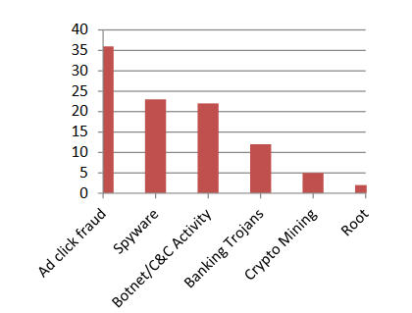
Figur1: threat targeting Google play breakdown the last year (Geneiatakis, D., 2019)

2.2. Distance Measure in K nearest Neighbor
MysteryBot was discovered in 2018, by ThreatFabric, it was the capability to combine the Ransomware keylogger and banking Trojan. MysteryBot was similar characteristics of LokiBot with C&C server. (Geneiatakis, D., 2019) performance evaluation of distance measures in KNN for mobile malware detection, related work was described with various mobile malware detection for android operating system which often based on machine learning classification technique, the approach is understandable to provide the valuable results to configure the technique, K nearest neighbors considering the different hyper techniques with different hyper parameter to emphasis the different measurement technique, the research proposed the various machine learning malware detection method over the android phone user by using the K Nearest neighbor.

Argumentative attacks on Mobile Malware Detection
Recent research show that (Xue, M., 2019) machine learning classification techniques has been widely used for computer security task including mobile malware detection & prevention, malware was global issue over the smart phone communication various competitor planned to create malware to capture the sensitive data of the competitor organization, malware was patent threat needs to improve the Google operating system which cause the serious issue. Capability of adversarial network, hence the machine learning detection solution deployed over the android operating system which needs some additional cost with Google API to plan the online analytics technique to capture the online malware attack which was major discovery with the Google operating system. This research effectively designed machine learning technique to generate the generative adversarial networks, by use of effective adversarial method the thresholds distortion method technique enable the developer the scan the real time malware capturing the real time sensitive information. Android dataset used and capture the 98% scanning accuracy to detect the malware from the android operating system. The generated samples dataset detect the malware from the android phone and report them.

Machine learning algorithm
Machine learning classifier for android malware detection (Agrawal, P. Trivedi, B., 2021) the growing popularity of android devices, it is also prone to malware attack, so there are various malware tools are available to scan the malware from android phone, but the most effective and static analysis technique used lot of resources to build the machine learning model to enable the user to detect various resources and manual overhead. By using of advance machine learning method enable the organization to deploy the employee’s real time mobile telecommunication malware detection system to protect the organization data. This research analyze the different malware detection technique which was based on machine learning classifier method, this research also highlights the research strength and weaknesses including future scope. The outcome of research present the various machine learning classification technique,
- Random forest classifier
- Naïve Bays
- Support vector machine
- Decision tree
Since the naïve bays classifier produced the highest accuracy rates and detection to scan and predict the malware from the android phone.

Machine learning classification malware detection using Opcode
Analysis of machine learning classifier proposed on (Ariff, N.A.M., 2020,) android malware detection tool using the Opcode mechanism. Android devices continuous to rise with more reliable application were introduced to make the daily routine task much easier and efficiently, mobile application framework uses the social media networking sites, including various other application technique including online banking, payment, online shopping web browsing, and other application and activities. Most of the application required user to provide private credential including private browsing experience to protect data from unknown sources, in the past various detection technique has been introduced to make daily task much easier. Therefore the enhance mobile detection used to enhance the security features which used against the malicious attack. Most of the android application provides the user permission to do the effective planning task to scan & capture the application in real time and detection various internal security credentials features to capture the advance problem of the android detection discovery. Hence the advance mobile malware detection techniques required to improve the malware detection system of the android phone. Machine learning classifier evaluated and validated based on the discovery of false positive and true positive rate, false positive rate classify the malicious mobile application. Mobile malware detection by using the method of opcode to classify the mobile operating system security several machine learning classifier method has been deployed to enhance the machine learning classification techniques with malware application detection discovery.
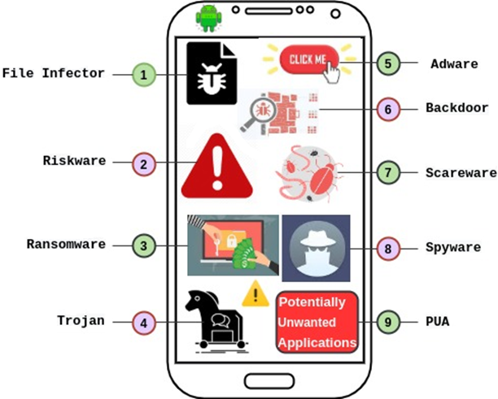
Figure 2: android malware families (source IT world Canada)

2.6 Understanding of Mobile Malware
Android mobile is one of common threats over the globe (IT World 2020) various e-commerce site and mobile banking applications needs security and protection to prevent from the malware attack beside this the hacking attack is also very common issues in central America. The common mobile malware is known as adware, which has been used some additional features to deploy with organized approach of mobile malware detection system. Since the number of android app is rise due to equitability and equivalence applications interface. The affected sector includes healthcare, finance, transportation, government, and various e-commerce platform various mobile attacker uses the techniques to capture the sophisticated intrusion detection system which was follows on different category, the understanding of malware detection system including series detection system. Adware present the spam and fake advertisements over the android phone application and redirect the user on the given link to capture the user data. Some common adware advertisement techniques based on weight loss, making money in less time, and bogus virus warning on screen. These given links are provided on real time internet web links and user experience to click on these links to redirect them on certain sites and scan the user data on the particular given link. Some common malware adware family are as follows:
- Gexin
- Batmobi
- Ewind
- Shedun
- Pandaad
- Appad
- Dianjin
- Gmobi
- Hummingbird
- Mobisec
- Loki
- Kyhub
Beside the other malware known as backdoor which might be exploits the device covertly by hiding in the background, and file infector contains which contaminate the file specially the executable APK file. PUA acts as unwanted interruption to normal activities perform by the device, since the Ransomware acts as crypto locker that encrypts the files and directories and demand the ransom from the user to access the his own data. Riskware, poses the risk to the potential vulnerability on the smart phone. Scareware serves as fear coaxer that ignites fear in the user mind and forces them to download malicious apps. Spyware indulges into spying activities to capture the useful information from the android phone and send them to remotely by using the internet service and controlled the server. Since the Trojan acts like imitator in the background android application which keeps stealing the application information on the running background task and send them directly on the other server on backend.

2.7 Reverse Engineering techniques
Reverse engineering is the process to determine the functionality of any object it used to obtain source code of the mobile app from the APK file. Various reverse engineering tools has been used to capture and detect the hidden malicious code inside the legitimate application various common reverse engineering tool based on android app including APK inspector APK tool, Bytecode viewer and Smali, and Jadx.

2.8 Security feature in Android

Google update Android operating system security features in android 11 version, various permission and security features has been added on it, android user makes it use the best to do the files permission and photos and video permission over the usages on the internet. Android update the security while opening and installing the application in the android phone. Google offers the application on time permission services to access the apps such as allow meet to take pictures and record video while using the app. Auto reset permission android 11 automatically reset the permission given to it, by means of Google app permission location and recording the audio and video on the real time implementations of applications. Background locations access, permanent location access, offers the on demand location access if the user granted the location service then operating system.

2.9 How to Secure Android Device
User do not download apps from unreliable sources, user might be encountered with download any unreliable app from unknown sources, even the application in Google play store are not secure, android 11 version and 12 is updated security version operating system of mobile network which enables the user to prevent the application from hacking attack and malware attack. Avoid third part app store which might be infect from viruses and hacking links which might be redirected the user to particular running server which cause the problem and capture the real time data over the internet. Say no to clickable link and does not click on fake and spam advertisement which might be capture the user information in real time and redirect them to another link various flashing and certain links make impression over the user choice, user might be interest on buying some grocery items and buying some clothes by using the online internet application. The use of common adware attack was very common malware threats which might be able the user to redirect them on certain link and capture the information in real time. User did not install any operating system update form unknown source until the android security and operating system makes any notification over the user operating system. since the used of various 100 of mobile application which might be able to slow down the performance of android operating system since the android operating system limited processing memory and storing memory so needs to improve the processing power and storing capacity. Latest android version are updated from malware attack in 2021, so there is need to improve the malware classification technique due to less number of classification technique are used in the past so the android operating system does not perform very well, but the malware threat still remain active but the implementation of machine learning classification techniques enable the Google operating system to update the android anti malware system. 3.4 Naïve Bays Classifier
Genetic global dictionary for storing mapping all distinct API calls to numbers in the dataset and pickles the dictionary, extract all features vectors for 8 test cases in dataset and pickles them, extract all features vectors for 600 apps in dataset and various features, and build the naïve bays classifier method. Naïve bays classifier of probability of A predict the value of probability of B value extract the featured values on dataset based on x1, x2 and x3 based value. Given hypothesis H and evidence E bays theorem states that relationship between the probability of the hypothesis before getting the evidence P(H) and the probability of the hypothesis after getting the evidence of P(H|E) is under estimation.

Figure 1: Probability distribution
In machine learning classification technique the frequency measures on likelihood values based on the bays theorem value. The fancy of naïve bays classify the target variable attributes based on the classification techniques of algorithm which founded on interesting attribute of dataset value build the machine learning model after feature selection from the given dataset and training and testing the dataset and builds the machine learning to check the precision call and F1 score of model. Naïve bays classification method for text classification implemented through the NaiveBaysText python class.

2.10 Support Vector Machine & Random Forest Classifier

Machine learning classifier has become the great tool to classify the malware from the android phone, in these days everyone is part of android phone and thousands of application has been customized and installed on android phone daily, beside this the rapid growth of malware designed for mobile devices. Android malware detection has increasingly important in the cyber security domain, using the standard machine learning classifier to classify and detect malware by using the dataset from kaggle and Github repository. ML classifier automatic detect the malware after feature selection and distinguish between the malware families and automate the detection and prevention process after training and testing the feature.
Exploring the malware dataset in python notebook and perform the data cleaning process and splitting the dataset into test and train and after feature selection building the model by using the random forest classifier and support vector machine classifier importing the python libraries, by using sklearn python library. Random forest evaluation on given dataset importing the confusion matrix and target train and test variable selection and predict the models. Building the confusion matrix with F1 score to validate the normalization process. Support vector machine classifier predict the values on given feature engineering selection in python notebook to predict the security permission on android phone attributes values given on building the dataset values on demands values , the model predict the highest accuracy rates with good precision call value on the machine learning prediction and classification technique method. Support vector generate the decision boundary. The flow method of machine learning as follows in the given diagram as below:

Figure 2: Flow Diagram

2.11 Decision Tree Classifier

Artificial intelligence method seen everywhere in our daily lives, the technology is become more powerful and interactive it is possible to simulate AI based cyber security attacks which performed using advanced malware incorporate to advanced feature evasion technique to avoid the security parameter in order to detect the extreme data security permission on android phone the objectives of malware detection and prevention system is to classify and obtain the correlation based feature selection by using the artificial neural network which compared with existing model and improved version to get the highest prediction rate, data processing and feature engineering selection in python to classify the dataset attribute values and perform data cleaning process to get the missing value and present the data feature selection to build the model in training and testing the feature selection of the model to validate the dataset values and build the models, finding the sensitive permission and taken to identify the malicious one. Malware is designed on particular malicious software to distort and interrupt the mobile or computer applications. Google play store is largest application store in the world, with commanding over 88% Android mobile shares in the market. Random forest is the core idea to generate multiple decision tree based on the feature selection of dataset.

2.12 Summary of Literature Review
Mobile malware detection and prevention system has been deployed in the past by using the various advance machine learning technique, various mobile malware attack family has been discussed and highlighted in this studies, so the research method is deeply discussed in the literature finding so there is need to implement the advance machine learning classification technique to scan and remove the malware from android phone. So literature suggested that various machine learning active algorithm deploy in the android phone to prevent from the malware attack. So the pattern of analysis followed by the python programming including jupyter notebook with anaconda IDE.
- Support vector machine classifier
- Naïve bays classifier
- Decision tree classification technique
- Multinomial classifier TFIDF Vectorizer
- NLP technique by using Machine learning algorithm
- Random forest classifier
Machine learning classification technique based on advance detection discovery based method which followed on dataset from the Github repository and Kaggle repository. Dataset downloaded from the above mentioned link from 3000 samples of android running application malware dataset which includes various malware and non-malware information, so the classification and detection discovery followed the pattern of machine learning algorithm classification method to suggest based on the real time detection techniques and choice. So there is need to use the latest android phone, Google operating system contains machine learning classification method.

Chapter # 3 Methodology

3.1 Introduction

Android Mobile phone malware detection and prevention necessary required to secure the user personal asset & records. Various mobile users uses various application from Google play store, even the play store is not secure due to unreliable apps, android user increasing daily , Operating system of android phone is very good & flexible & inexpensive so every type of user is in range to buy them. Google developed in Java programming beside this java kernel written in c language, android emulator is main player of interface in which application exist to be tested before deploying. Latest android 11, and 12 version is much secured and reliable with stable security version, so there is need to secure the android phone from malware threat, adware is common malware which was used as playing card with interactive advertisements & promotions & gifts discounts links. Trojan is very dangerous malware which capture adware, worm and other malware from the mobile operating system. This research is going to develop machine learning classifier by using the dataset to detect and prevent the malware observation using the python programing. The common objectives of malware to destroy cyber security confidentiality and integrity by theft of data, commonly attacked denial of service, mobile hijacking, draining the power flooding the device & exploited from known source. Malware might be damage mobile SMS, Bluetooth attack, phone jail breaking install application without permissions and premium rate attack deliver valuable content to mobile device and spyware attack.

3.2 Research Philosophy
T mobile G1 was first android phone, key based event might be interrupt the user for doing any event on the phone. Android 1.0 released in 2008, the operating system including Google map, HTML browser with Gmail service. Google play store is called Google market in which various Google application stores. In 2009 android 1.1 arrived with details of business reviews including text messages, allow to speaker the phone, show and hide the dial pad. Beside this in 2009 android release 1.5 cupcake first version of Google search screen on display on galaxy phone the ability to upload video on YouTube, automatic screen rotation, third party keyboard support, copy & paste features, web browser and the ability to check the phone also in 2009 Google release android 1.6 Donut version support to use CDMA based network support different screen sizes it included search box to quick switching function from camera to other event including power control WIFI, GPA, Bluetooth functionality , beside this Google releases android 2.0 version Éclair which support text to speech function including multiple accounts, Google maps navigation minor changes in API. Android release Froyo in 2010 which android 2.2 version several new feature, mobile hot spot WIFI, push notification and GINGER Bread in 2010 Nexus phone co developed by Google and Samsung updated UI design extra-large size and video resolution support multi input touch, in 2011 android release honeycomb virtual button has been introduced and Android OREO in 2017 & android 9.0 in 2018 PIE version improved battery life, improve navigation operating security & buttons. Android 11 released in 2020 conversation central in the messages with front of notification including chat bubbles long pressing the power button it proceed to new interface introducing new security features to secure user data , user will allows to access app only once, next time the permission required to access the app from the phone. First malware attack found in android phone Ransomware attack in 2010 which flash player name in android phone. In 2011 uninstalling apps automatically in phone due to malware attack happened due to system update automatically installed update without user permission. In 2020 latest android phone Google introduced built in machine learning classification technique to update the security features in android 11 version.

3.3 Data Interpretation
Mobile malware is malicious software that target mobile phone or wireless enabled personal digital assistance by causing the collapse on the operating system and loss or leakage of confidential information, beside this wireless phone PDA network are more complex, safety and security are commonly used to protect the malware attack. Android malware detection if there is presence of malware by using the attributes extracted from android applications as feature. Since the dataset values belong to either 0 or 1 only label encoding of last column will be enough, by training and testing the feature of dataset including train feature and label feature build the Keras sequential model, and predict the model after training and testing the dataset and build the machine learning models to get the F1 score and precision recall value, confusion matrix build to inform the predicted label value and true label value from the dataset. At kaggle competition dataset attribute name transact, on service, bind service, attach interface, service connection, android operating system binder, SENS SMS etc. and dataset at Github the attribute selection android permission access all downloads, android permission access Bluetooth share, android permission access on cache file system, android permission access on cache properties. The neural network model in static model has a bias towards bengin. The dataset name is android malware detection by analyzing permission on android phone. Various applications needs permission before launching, it includes jupyter notebook to prepared the dataset and create the model, dataset created using androgurad. Retrained model using the genetic algorithm techniques.

3.4 Research Strategy
Research strategies of this research used with advance machine learning technique to predict the android phone permission dataset. Classification of android apps done by using the pseudo dynamic analysis of system API calls sequences, developed on deep learning & convolutional neural network classifier including LSTM model deep neural network classify of naïve bays classifier method. Machine learning classification uses the supervised machine learning models.

3.5 Data collection Method

Primary Dataset:
Primary dataset has been collected from Github and Kaggle repository which is used to predict the malware security permission attribute values on android phone. Dataset attribute selection has been made from both kaggle and Github repository which means to validate the feature selection attribute. (https://github.com/anoopmsivadas/android-malware-detection)

Secondary Dataset:
Secondary dataset has been collected from Google scholars, IEEE Journals, IEEE Xplore, IEEE conference paper, ACM library and MDPI research including peer review journals article with good impact factor. Dataset was part of other research which does not means to copy from other sources, it get the idea and generate the research plot.

3.6 Data Analysis Method
Static and dynamic malware analysis (Chapaneri, R., 2020) using the machine learning classification technique as mentioned. Malware is section of programing written in intention of harming the mobile device and capture data and locations. Data analytics techniques based on identify the patter in dataset and demonstrate the static and dynamic analysis which learns the machine learning model various machine learning algorithm used to classify the dataset and obtain the F1 score and precision recall score with highest accuracy rate, various machine learning method used such as random forest decision tree classifier, support vector machine and naïve bays classifier including neural network modeling to get the highest accuracies about 98% implemented the dynamic analysis. (Ali, W. Abdulghafor, R., 2020) mobile malware detection & prevention based on supervised machine learning modeling after training and testing the feature engineering dataset value, android zero app cannot be detected which formulated on signature based analysis due to learn the existing feature and build the new feature model to detect the malware values from the dataset by using random forest decision tree and SVM, including naïve bays classifier which are common to detect. In previous releases of android operating system which does not support security features, now the 11 version of android is stable and secured from third party hacking & malware activity.

3.7 Research Consequences

Research result formulated on the machine learning classification technique detection dataset columns values which based on android permission resulted in column, certain columns in dataset based on same value for APK files and analyzed information predicted on cleaning the value, removing null values building feature engineering, removing highly correlated feature engineering and testing and train the dataset to select the target variable from the dataset and build the machine learning model. Distribution of malicious and bengin file in the dataset present the graphical view of the permission attribute value the dataset contains the balanced samples of malicious attribute value achieve through the random sampling method. Since the android applications represented from Google application play store the android API version improved on latest releases of android operating system, SVM classifier good classifier of machine learning tool beside this naïve bays classifier analyze them on text feature selection and takes decision on the selection attribute values which founded on binary classification which mean 0 and 1 technique. Model validation and tuning towards the end of the model development, the research used F1 score to generate matrix which helps the research to evaluate the model performance. The validation model selection constructed on by training and testing the dataset target variable values & feature engineering obtain the data cleaning process and build the machine learning models.

3.8 Research Sources

Research sources as follows

- Github
- Kaggle
- IEEE
- Google Scholars
- ACM Digital library
- MDPI Research
- Google Scholars
- Anaconda Python
- Jupyter notebook
- Machine learning & deep learning python libraries.

3.9 Ethical Concern

This research studies of universal values based on mobile phone which is essential equality of both men and women which is natural rights to use the mobile device for both gender to solves their daily lives problem and business & education concern. The right behavior of this research to used machine learning modeling to avoid malware and remove them from the phone device and wrong behavior of doing the malware activities such as download software’s from illegal sites, Google play stores is reliable platform for downloading the software and applications from the Google server. Ethical behavior confirms to generally accept social norms, ethical codes difficult in some situation to enable the mobile malware without any reason for deploying the anti-malware tool in mobile device. This research ethics contribute to society and mankind avoid harm to others be honest and trustworthy be fair and don’t discriminate honor property rights including mobile data sharing rights Bluetooth sharing rights and application sharing permission is mandatory before using the other user mobile device. This research conduct in good faith including social moral values, it meets the scientific & artificial intelligence standards the results describes the guidance to society members and culture to avoid unreliable source and data sharing activity, because mobile phone contains sensitive data & banking information. Mobile subject treat well, reduce coercive and reward response, honestly I saying not lying stealing or cheating the other research works not hiding the truth for someone and showing the good and truthful character.

Chapter # 4 Results & Analysis

4.1 Support Vector Machine Classifier, Random Forest Classifier, Decision Tree Classifier

Highly efficient random forest based malware detection (Cheng, L., 2018) framework for android phone, in these days android phone is rapidly the growing industry of telephonic network, various malware attacked by the android phone in certain period of time to capture the sensitive data, mobile phone posing to increasing the threats including various security threats. Google’s android is the most popular smart phone platform in the world of permission mechanism, this research propose machine learning classification technique, feature group selection including permission rate mined to characterize each android application and the most essential component of random forest classifier actively works to detect the app either it contain with malicious or not. The proposed performance method is evaluated on the actual data set using tenfold cross validation and the experiment result presented that which present the high accuracy rate formulated on 89.91% rate performance accuracy analysis of malicious android app dataset. (Hofmann, M., 2017) android is most popular operating system with share of 86% of mobile phone user, its open source operating system to support various third party application to executes within the android phone device. Google provides security features that built in under the android operating system releases but the issues is still exist by obtaining malware from the outsources by redirect the user to third party link to open malware applications by using the adware and other malware threats exists openly in android device, however the static and dynamic analysis of machine learning analysis provide guard against such analysis to secure the android application by scanning the machine learning feature selection to best prediction and remove malware from the app. The study conduct to scan the 216 malicious app to construct feature vector of training and testing by selection various feature selection, the system call behavior detected the 216 malicious app and 278 normal app to develop the feature vector for training the classifier. Machine learning data classification techniques has been used with various method to predict and detect the malware apps by scanning code of APK. Including decision tree, random forest, gradient boost, support vector KNN, artificial neural network including deep learning approach has been applied on dataset. There are three feature ranking technique has been identified by selecting the suitable feature selection set of 337 attributes of dataset system calls, the techniques ranks the various feature selection method based on chi square static and correlation analysis by determining weights of feature, the feature selection method founded on high & low rank to predict the performance analysis of android application behavior which consist of malicious code and finally the experiment result present with various machine learning method support vector machine classifier through selecting feature through the correlation analysis of including accuracy of 97% and achieve the recall performance of 98% by identifying the malicious apps, the contribution of system call identifying set of performance by predicting the malicious apps of android phone.

4.2 Programing Task

Python libraries to validate the basic operation

Importing python libraries
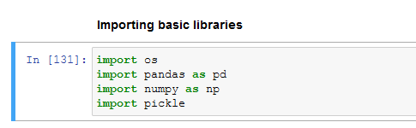

Loading dataset
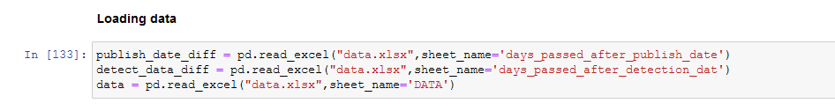

4.3 Data Cleaning

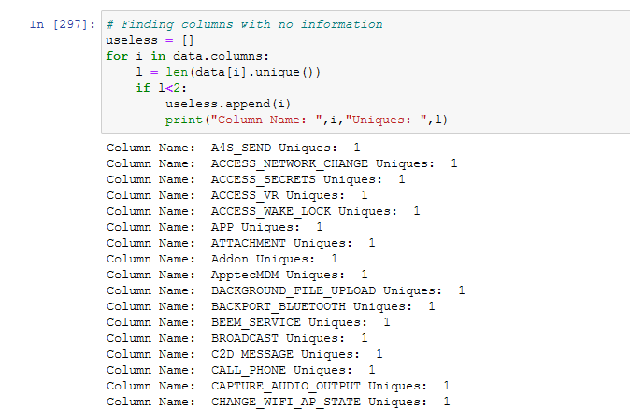

Drop column with following names due to their uniqueness and low information quality

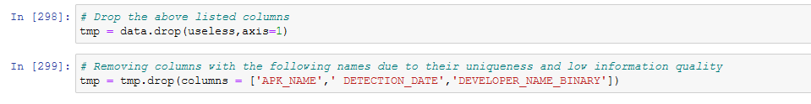

Calculating the days Elapsed since uploading on play store and days since first detection result has been made.

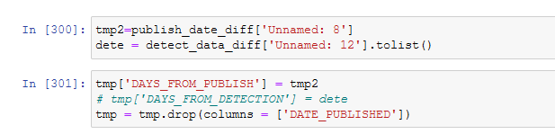

4.4 Removing Null Values and Fixing data types for column

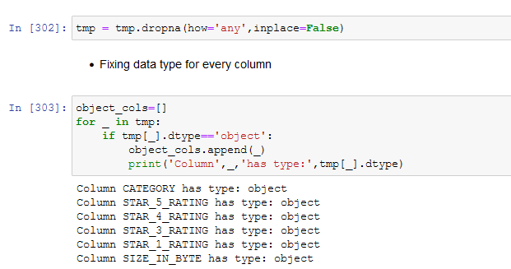

4.5 Convert text columns to integer data type

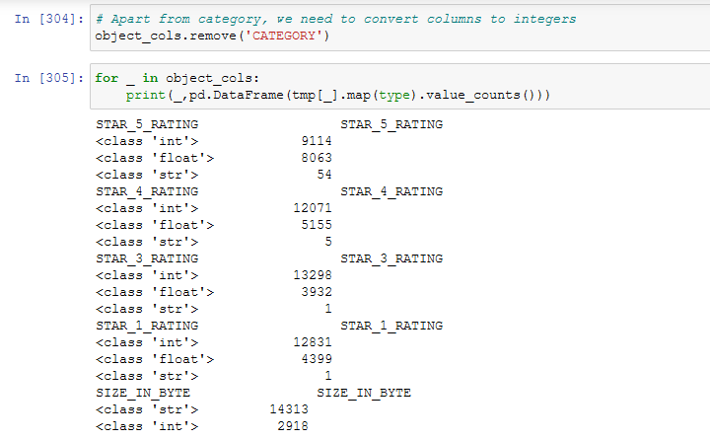

4.6 Stripping white spaces in columns

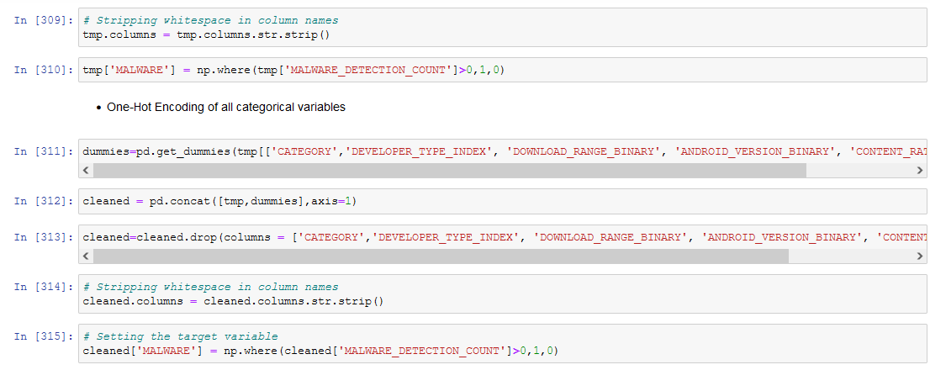

4.7 Top 10 permission rating Bar graph

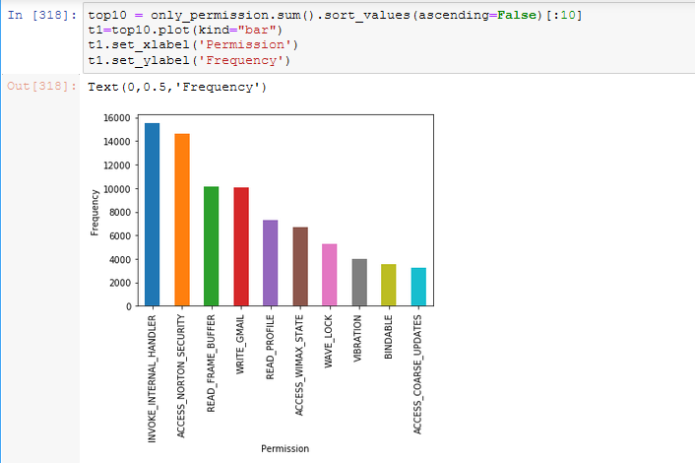

4.8 Data Visualization

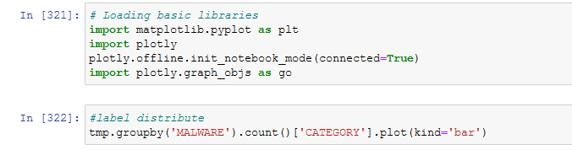

4.9 Bar Plot

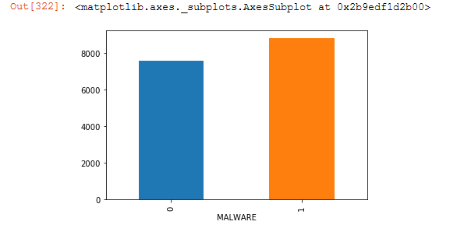

4.10 Distribution plot of Rating of Malicious App
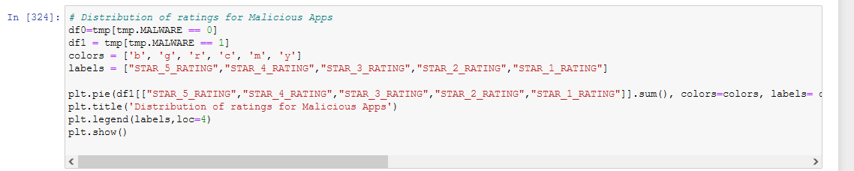

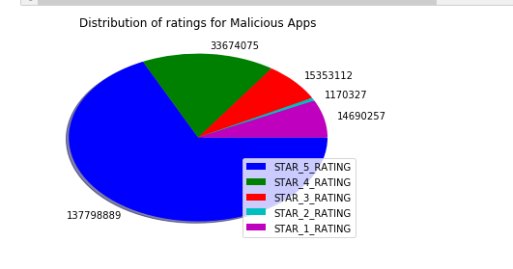

4.11 Distribution of rating of Benign App

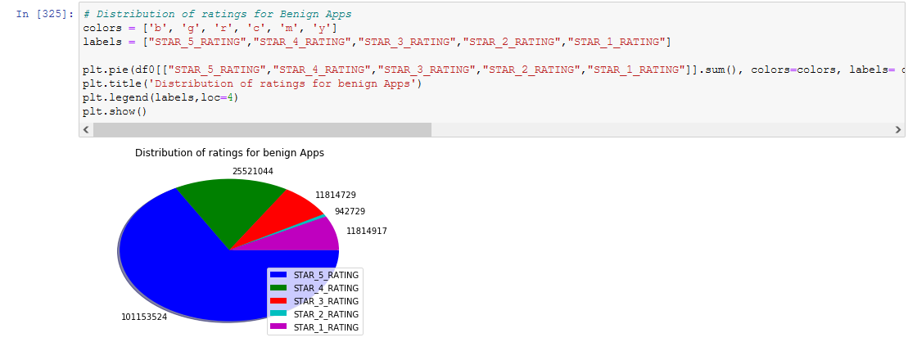

4.12 Malicious Distribution of Malware App

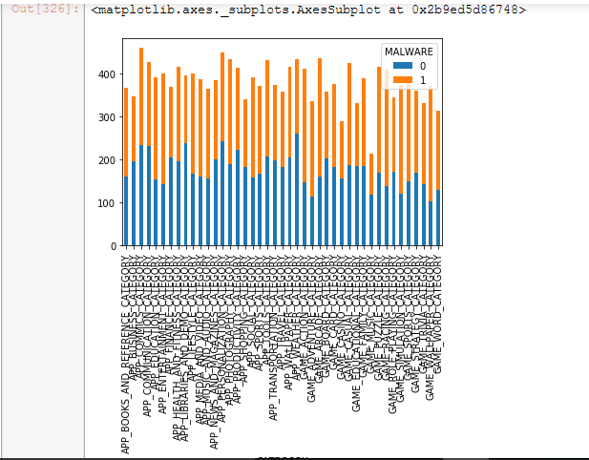

Android Version Malicious Ratio

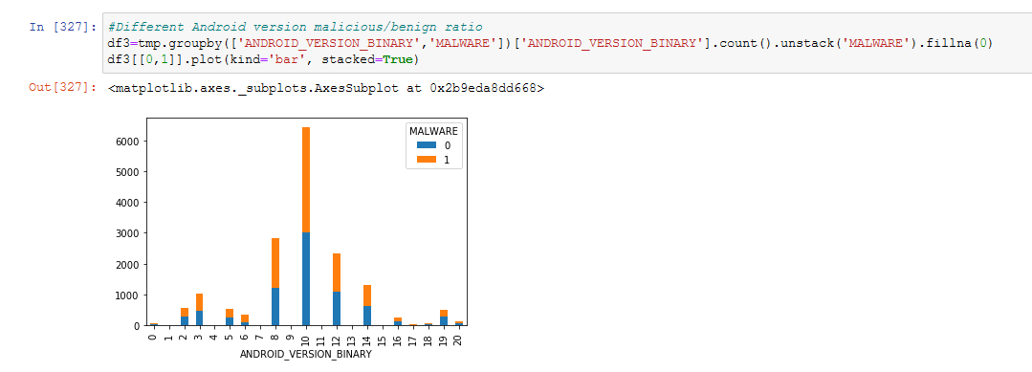

4.14 Distribution days of publish Histogram

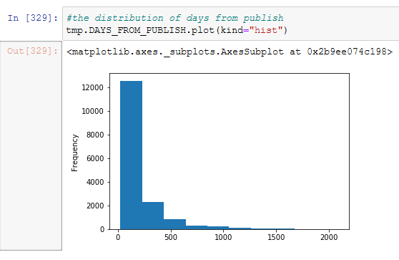

4.15 Machine learning python libraries

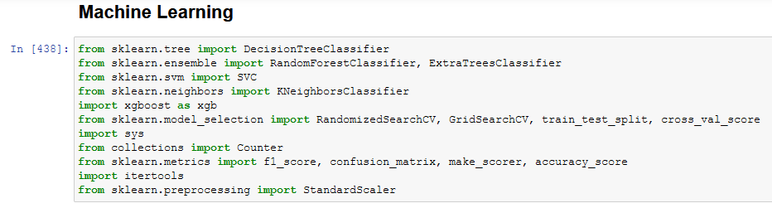Removing highly correlated features decrease redundancy of features

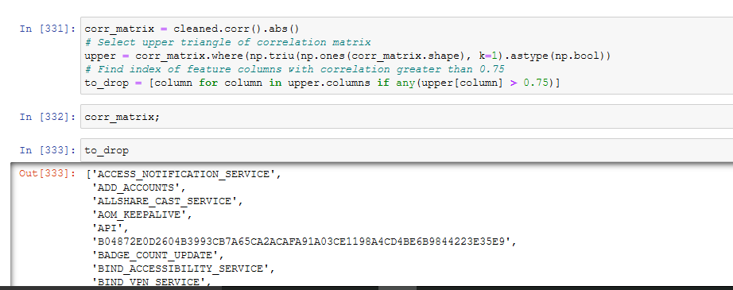

4.16 Removing unnecessary columns from the dataset

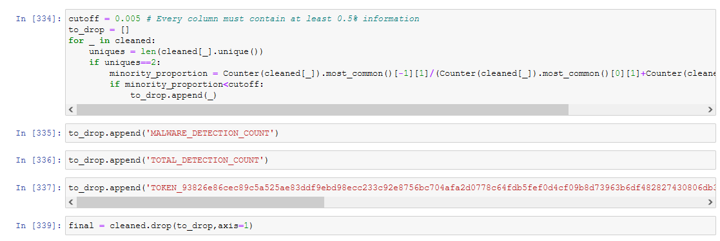

4.17 StandardScaler feature

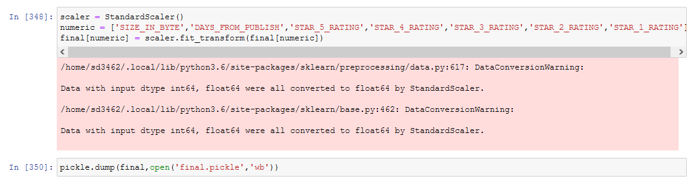

4.18 Training and testing features Model development

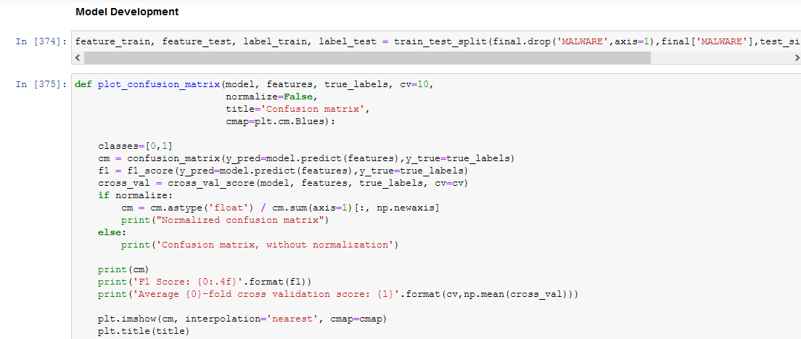

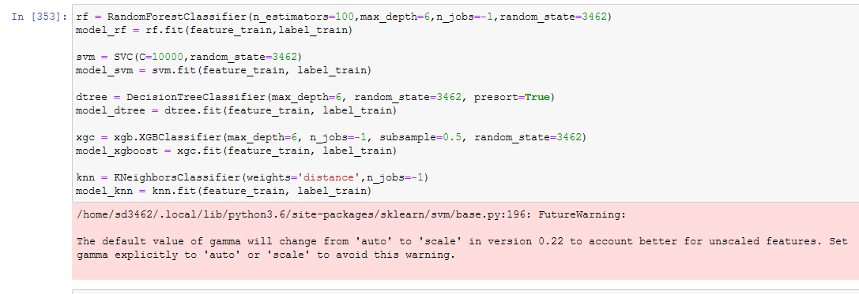

4.19 Non Normalized Confusion Matrix

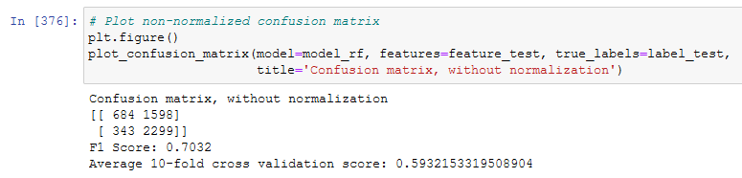
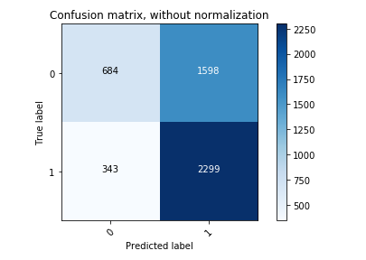

4.20 Non Normalized Confusion Matrix

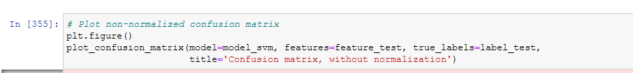

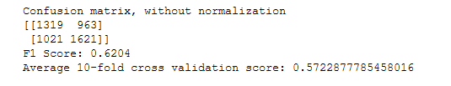
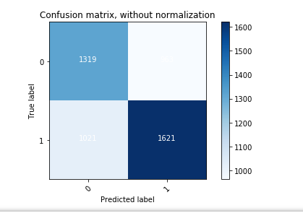
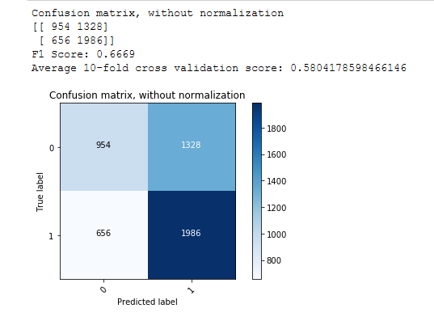
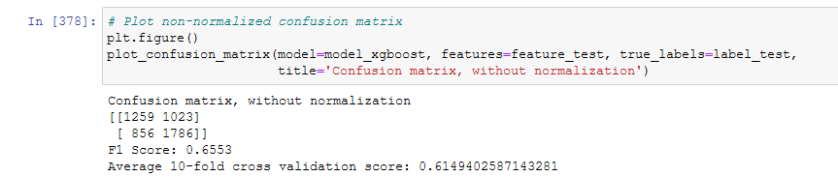
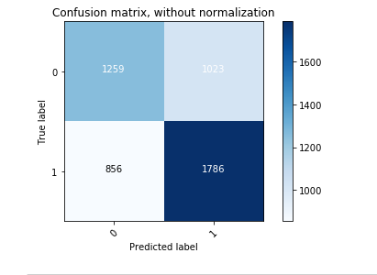
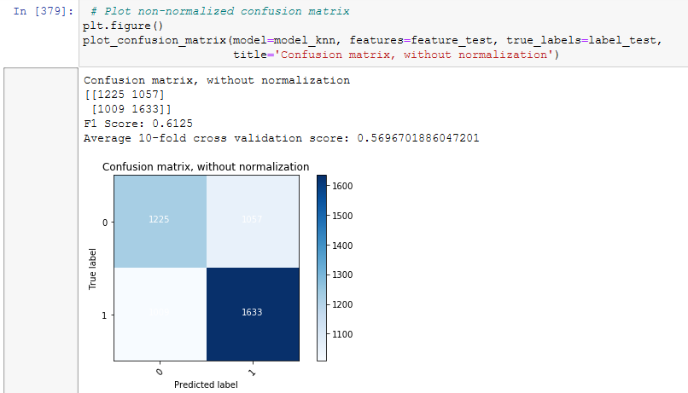

4.21 Model Tuning
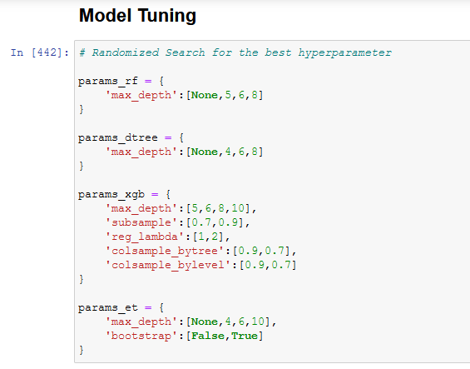
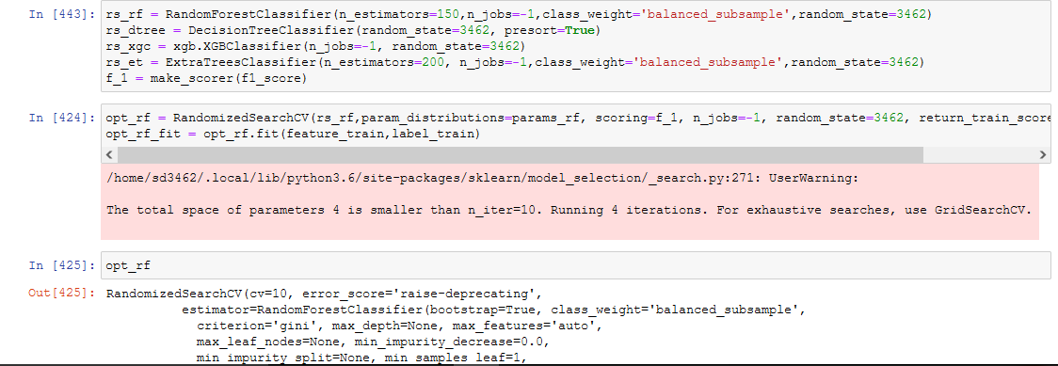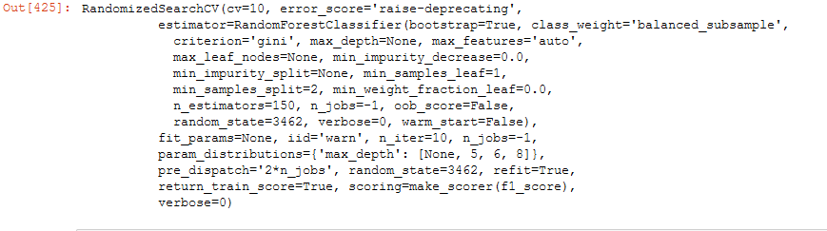

4.22 Non Normalized Confusion Matrix Plot

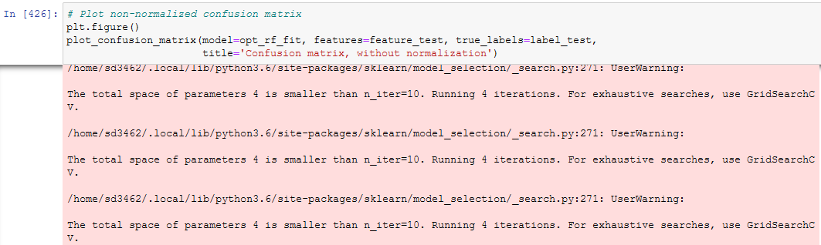
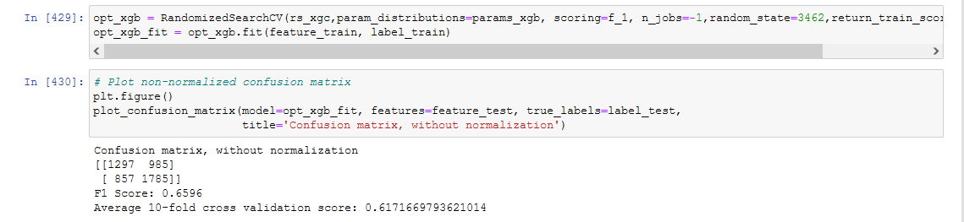
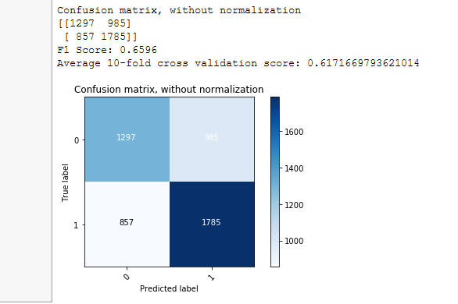

4.23 Outcome

Confusion matrix without normalization

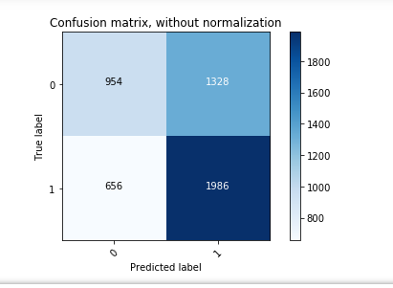

The experiential assessment numerous machine learning replicas aided us accomplish that the decision tree performs the best on the data. The evaluation result of metric score is presented with F1 score which takes into account the precision and the recall of every classifier and while it is noted that the detect true positive which is important to reduce false positive and false negatives. The false positive result might be cause inconvenience to the user while false negatives would be unsafe to the user safety and privacy, (Ali, W., 2019) hybrid intelligent android malware detection method using support vector machine classifier which proposed on genetic algorithm, the optimization problem in support vector machine is solving using the genetic algorithm technique with practical swarm optimization referred to DROID-HESVMPSO approach to achieve the best detection result obtaining by using the machine learning techniques including hybrid malware detection techniques approach. When the feature set was constructed the classified model were trained & validated feature ranking & selection technique has been identified on performance and after application comparison.

4.24 Optimal classifier configuration

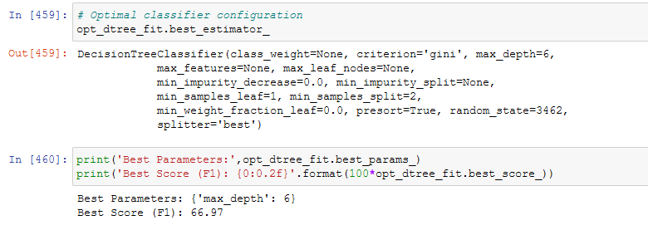

4.25 Decision Tree classifier result

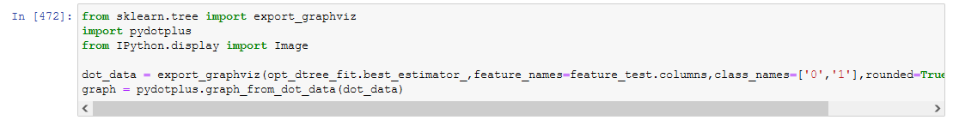

Decision Tree classifier result 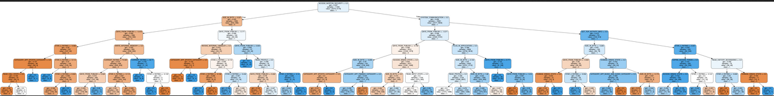

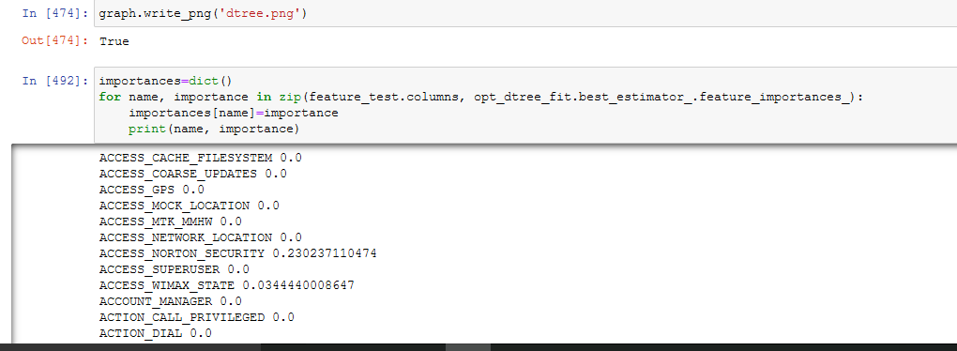
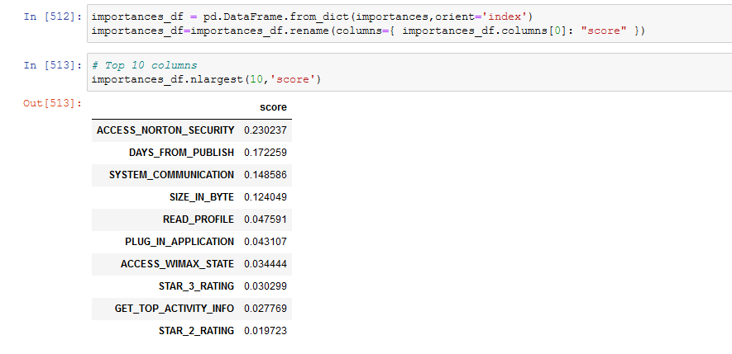

4.26 Artificial Neural Network with SVM

Dataset

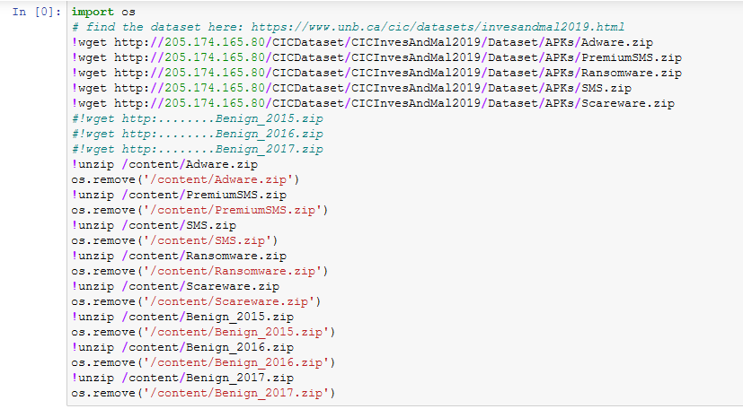

4.27 Importing Libraries

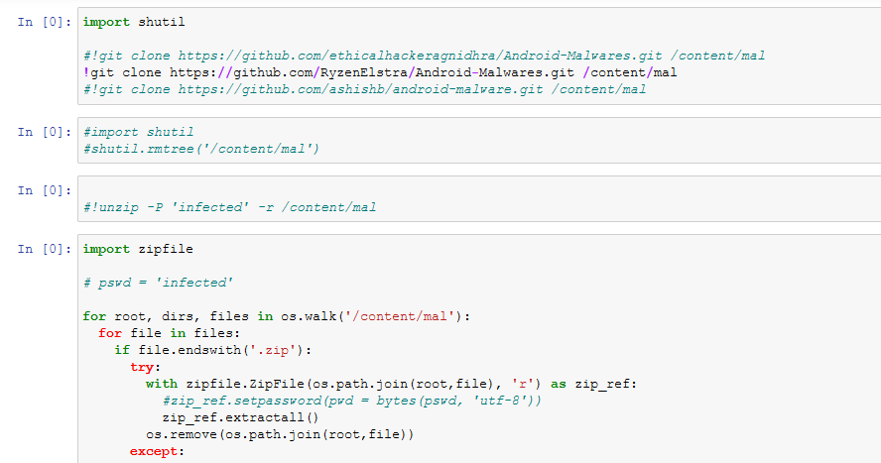

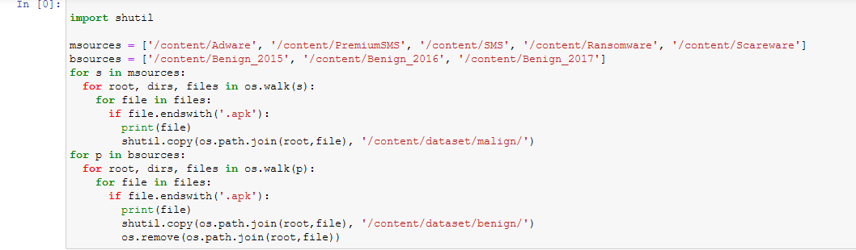

4.28 Importing APK libraries

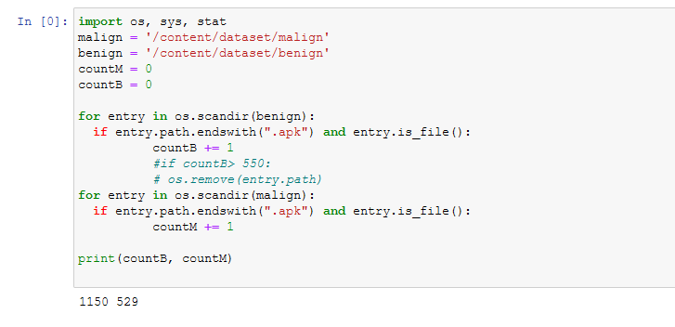

4.29 Importing System, OS Statistical

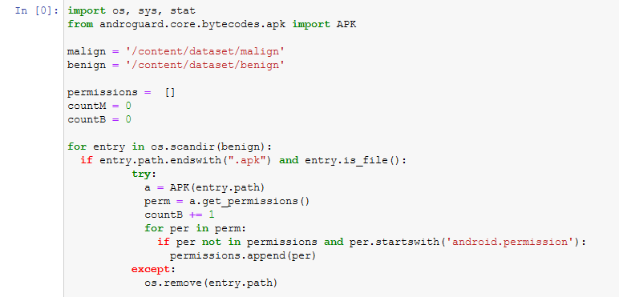

4.30 Print Predicted validated Data value

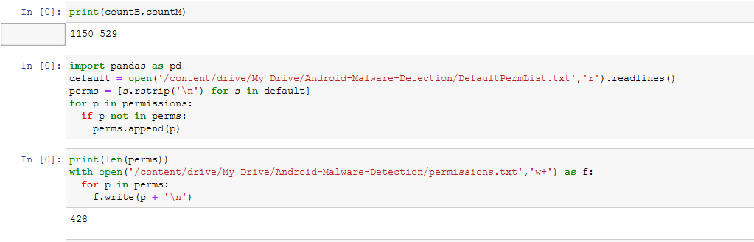

4.31 Support vector machine with Grid search to tune model

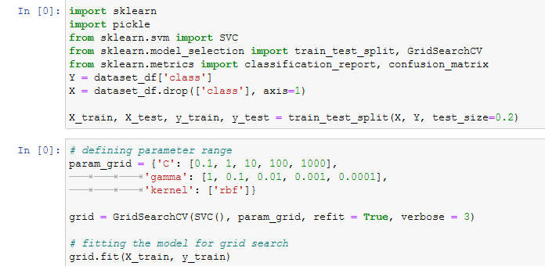

EPOCH Call Kernel

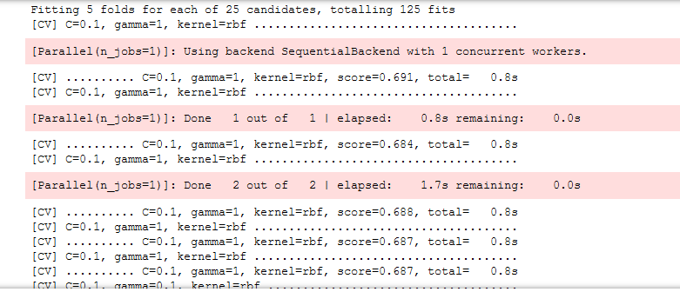

4.32 Classification Report

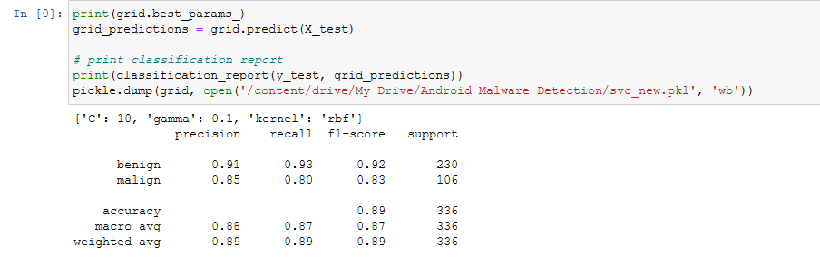

Prediction
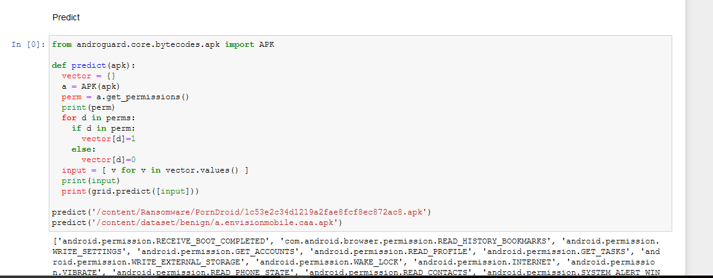

4.33 Android Permission Data

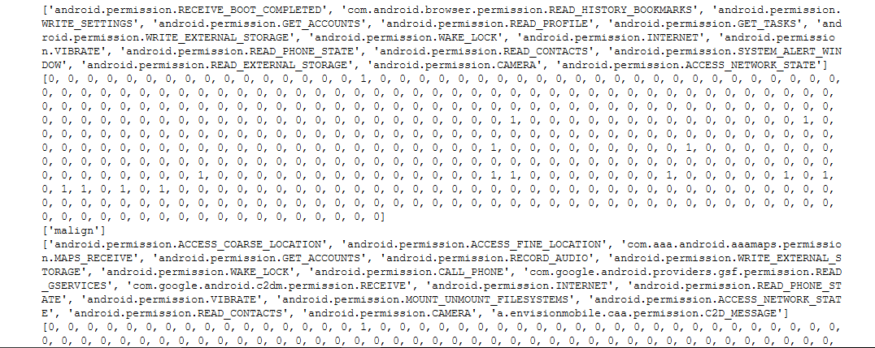

4.34 Multilayer Perceptron (Artificial neural network)

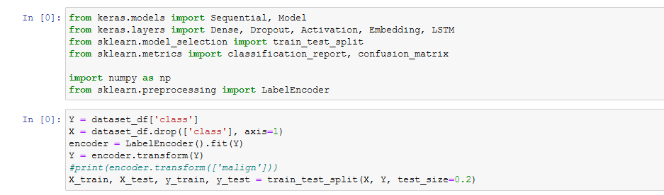

Sequential RELU Metrics

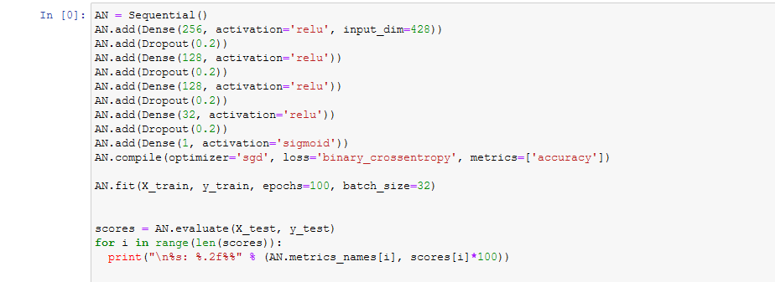
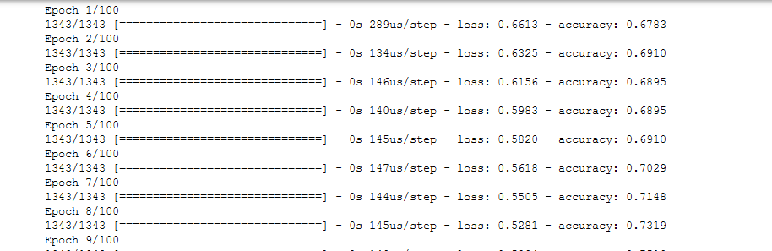

During the data preprocessing the steps involved by scanning the feature selection to identifying the attribute in zero variance which was removed. The feature corresponds to the system call which were never invoked by set of samples to proceed the with 337 system calls and 43 attributes. The classification report constructed formulated on training dataset based on input and output pairs to analyze the algorithms which learn the mapping functions, the gradient boosting tree by training and testing the random data and growing the weighted version of dataset by obtaining the correlated regions which formulated on different values. SVM technique based on statistical theory the linear SVM techniques identifying the hyperplanes with maximum margins of two separate value of classes.

Android API APK

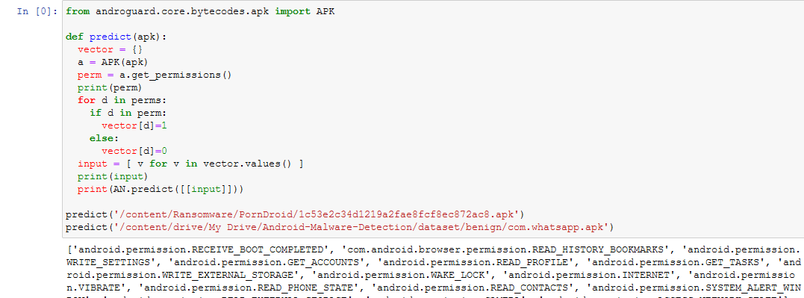

Android malware prediction accuracy

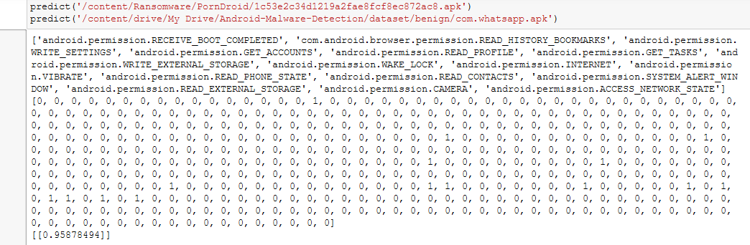

Android malware prediction accuracy

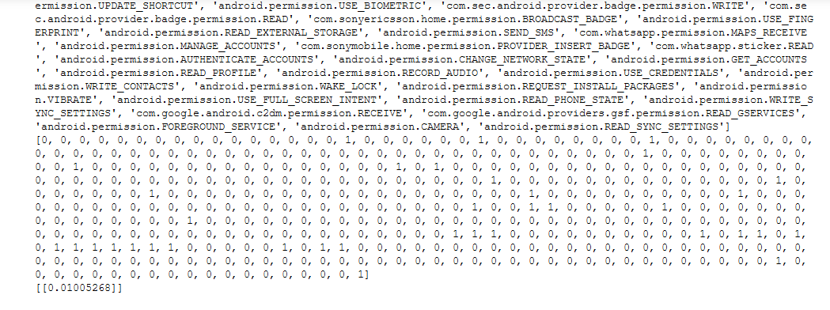

4.35 Analysis

Mobile malware detection using the machine learning classifier (Lukman, S., 2017) in regards to latest technological platform, smart phone and other mobile devices facing issues due to malware, it caused problematic situation over the internet web. Android mobile platform using the various Google operating system API perform various mobile malware detection & prevention including various computing platform. Dataset consist of both benign and malicious applications were installed on android device to analyze the various pattern of behavioral network rules. This research generate the system metrics feature vector from each app by executing the controlled environment of machine learning operation in order to achieve the accuracy of malicious malware detection from the security dataset of android phone. Various machine learning algorithm has been proposed and used in python notebook in order to achieve the great efficiency of machine learning detection accuracy Decision tree, KNN, SVM, Multilayer perceptron neural network with naïve bays classifier random forest classify the app as benign or malware, individual algorithm evaluate on different criteria of prediction and detection of machine learning accuracy, the resultant outcomes of research evaluate that the random forest and support vector machine classifier predict the best accuracy outcomes including effective techniques of malware detection. (Sung, A.H., 2018) evaluated machine learning models for android malware detection, popular android mobile billions of active users, developer deploy malware for various purposes, Google play store providing the security features to Google app by user ID based security tool in which the hacker identification easy to prone while capturing the sensitive data from the android phone. The system permission applications needs various security features from different user identification based configurations, machine learning static classification method has been implemented to test the android malware dataset, android operating system scans various system application while installing the new app, this research present the 5560 malware samples including android permission APK dataset with 5560 Benign samples of DERBIN dataset to validate and predict the accuracy performance including F1 score and precision call, with 94% accuracy achieved (J. Lin, X., 2015) effective behavior based android malware detection system, rapid growing of android application become challenging issues with research to avoid malware from the android phone. The behavioral analysis predict the android malware detection by using SVM and decision tree classification technique the promising approach predict the accuracy and resilience to malware alternatives the android API with Google interface to scan the mobile applications to predict the sensitive application behavior. Results of this research based on machine learning technique which would evaluate the different ML algorithm such as Support vector machine, random forest naive bays, decision tree and genetic algorithm classifier technique, experiment conducted on 1136 real world samples composed of various malware samples including malware and benign application, the evaluation results present that the behavior system of android application used to predict the malware detection composed of application behavior method. (Verma, H.K., 2020) static feature selection based method including effective machine learning method effective large scale detection method dataset extracted from online API tool and unzip in python notebook and predict the security features of APK application to validate the outcomes with precision recall and F1 score prediction of machine learning principle component analysis used the feature selection approach by training and testing the dataset and building the random forest and support vector and decision tree classifier to validate the result by achieving the dataset trained and tested approach and getting the random forest classifier accuracy with 96.5% classification accuracy including classification report of confusion matrix.

4.36 Genetics Algorithm
Using python notebook by importing various machine learning libraries and perform and malware detection by using the Github and Kaggle repository dataset. (Doğru, I.A., 2019.) Permission based android malware detection system using the feature selection of Genetic algorithm since the android is Linux based open source Google operating system, android developer mostly target android devices to capture the sensitive data, machine learning method rapidly used in android malware analysis by various genetic based techniques by combining the support vector machine classifier to other random forest and decision tree classifier and get the highest prediction accuracy of 98% with 16 selected permission using the dataset sample of 1740 consisting of 1119 malware and 621 benign samples.

4.37 Programing Task

Importing Python Libraries in Notebook

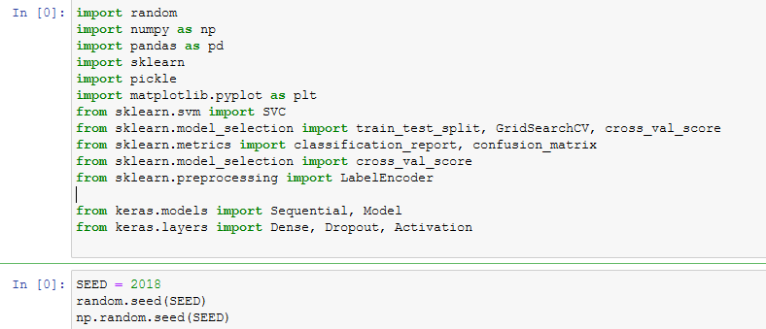

Importing dataset

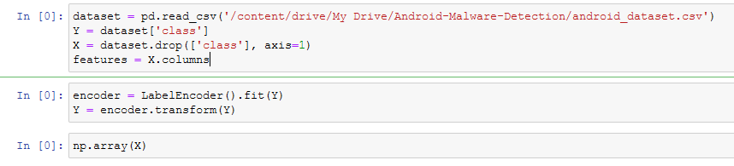

SVC Mean Squared ERROR

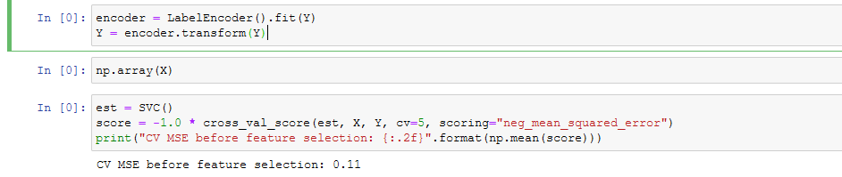

Genetic Selector

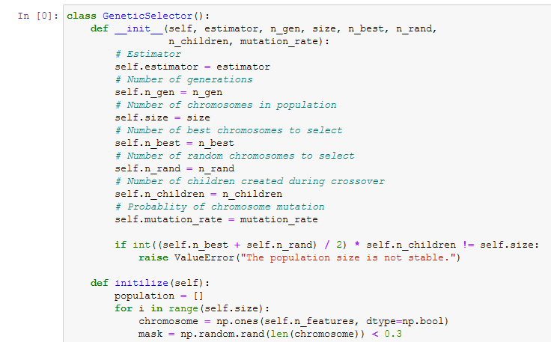

Score Generation

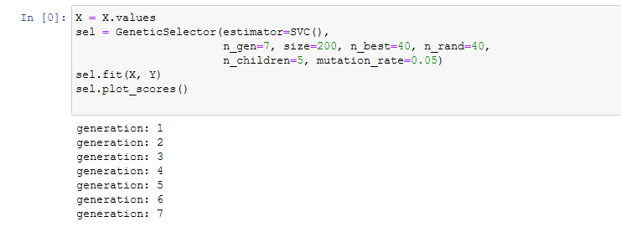

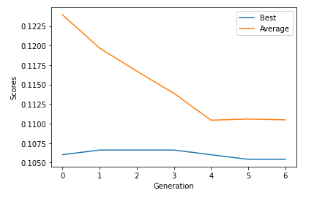

Mean square ERROR after feature selection

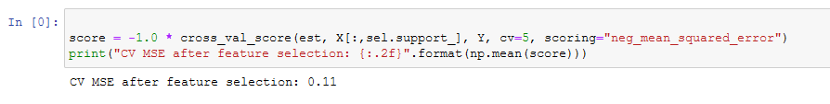

Import Pickle library

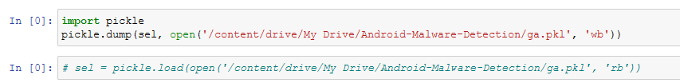

Trainings & Testing dataset

ANN Sequential

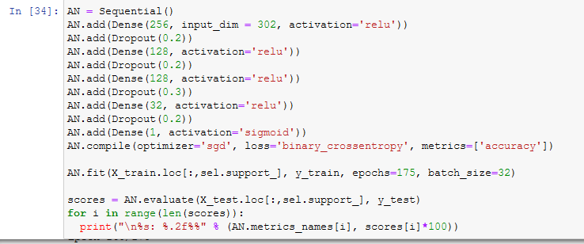

EPOCH

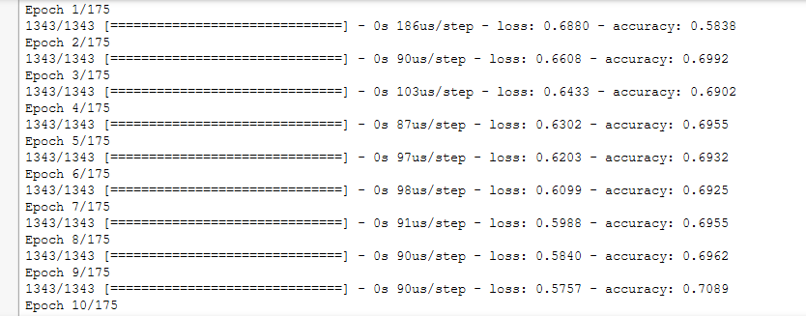

Andro Guard
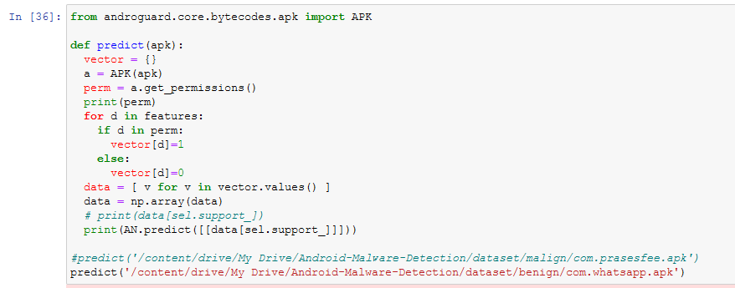

SVC
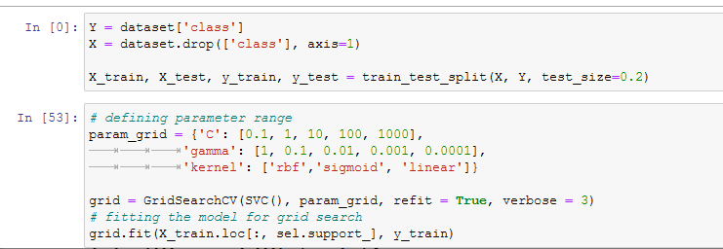

Classification Report

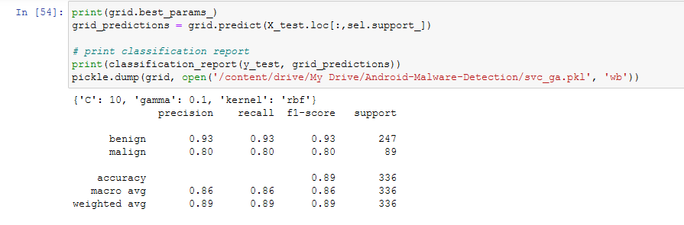

4.38 Results & Analysis

Decision tree is classification algorithm which classify the various object of attribute to validate the different usages of malware detection and prevention. The decision tree classifier internally classify the node with edge to edge connected nodes based on the dataset attribute which validated the internal nodes which classify the internal label (Darmawan, M.F., 2021) android malware family detection using the classification method of machine learning algorithm various malicious software application of android identified & predicted formulated on the dataset value the resultant feature selection approach used to identify the different attribute with false positive and false negative value the ability to identify the malware from the android device which prevent on different classification techniques. The machine learning and deep learning classifier support vector machine, KNN, Naïve bays decision tree, random forest tree classifier which formulated on 25 malware families is converted into fixed gray scale image and the gray scale image transformed on 100x100 size which based on single format into 100000 columns value the phase test identify the pattern of predicted attribute value with 92% accuracy of random forest classifier and 88% accuracy of support vector machine classifier & 81% accuracy of decision tree classifier which revealed the best accuracy & prediction method. (D. Roshni, A., 2022) dynamic analysis based mobile malware classification using the supervised machine learning method, during the pandemic period, mobile hacking and mobile malware attacked happened to capture the essential information from cell phone and target the person and track the location, supervised machine learning models investigate the machine learning algorithm which formulated on classify the malware attacks, the systematic method of supervised machine learning approach detect the malware data points and classify them into binary classification to detect the malware of benign is main component of malware attack which needs to identify theme from the dataset values. The objective of this research is to investigate the mobile malware attack to classify them by using the machine learning approach and identify the pattern with high efficacy rate, it is important to note that the performance measure like precision call and F1 score has been measured and classify with great prediction accuracy rate including mean absolute error and root mean square error are experimented to conduct the benchmark analysis of malware detection and prevention to discover the latest roll back analysis of machine learning modeling, it is suggested that the latest android 11, and 12 version based on good security features with great machine learning classifier method. Machine learning method such as decision tree, support vector genetic algorithm random forest classifier Ada Boost, multilayer perceptron are experimented and discussed in this research.
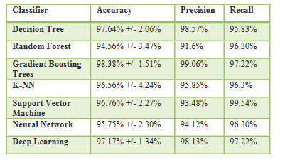
Table 1: performance of classification after feature selection using the information gain (RENJITH, P., 2021)
The evaluation of machine learning (Obuzor, Z., 2022) algorithm tested on IOT system to predict the malware attack with OPCODE prediction. The popularity of advanced machine learning approach including various applications to scan & predict the various identification and detection approach to identify and secure the malware attack from the system. The OPCODE method is used to classify the malware from IOT system and the OPCODE was generated from dissembled malware program. The supervised machine learning method used to obtain the random forest classification technique including decision tree classification approach naïve bays support vector have been implemented in research and the experiment result represented the classification report of including 512 IOT benign and malware files showed the random forest classifier which performed the best accuracy & prevention techniques including better accuracy of 100% (Mišić, V.B., 2022) android malware detection using feature ranking of permission the use of android permission including effective differentiation method to identify the benign and malware app the extraction of android permission eliminate the zero impact of which apply feature ranking technique including chi-square test and fisher exact test to rank the additional filter to test them. The comparative result has been tested and implemented by obtaining the classification report and summary report of machine learning which essentially tested and implemented based on the small set of relevant permission. The decision tree, support vector machine and random forest classifier used to detect the malware app the analysis indicate the approach with better accuracy and great F1 score and reported the other features which proposed on different attributed values. Beside this the random forest classifier approach which combination of fisher exact test, and achieve the 99% accuracy in 92% accuracy in F score which corresponds to positive rate of dataset question to formulate the research problem, the improved results of this research with 99% accuracy of prediction including great precision call system approach which validated the android malware app infected with malware or not with false positive rate has been tested which considered on various malware detection & prevention method. (CHANDRIKA, A.T.B 2021) android malware detecting method by using of extra trees classification approach which discriminant feature selection, and the feature selected on training and testing the machine learning classification decision tree, random forest tree, genetic algorithm including support vector machine learning without using hyper parameter tuning and the identification capability used with different learning method of feature selection & proposed with various parameter tuning approach. The experiment result present that the validation of extra tree classifier method designed to proposed the tree classification method the optimization method of feature subset techniques helping in reduction of feature reduction dimension to less than the half of original dataset. The classification report accuracy about to 70% prediction accuracy which maintained the hyper parameter tuning while working on much reduced feature dimensions there having positive impact on computational complexity of prediction & detection of learning classification techniques approach has been tested carefully (RENJITH, P., 2021) performance metric system for malicious URL data using revised random forest algorithm phishers used ridicules emails phishing programing takes to phishing cost which developed to capture the data from mobile phone, the common use of phishing attack served billions dollar every year, beside this phishers used satirized emails phishing programming to take the budgeting outcome to proposed the record of individual data samples including various information, phishing attack capture the device user name and password and sends link to redirect them to on particular link which investigate different highlight of machine learning calculations. The utilized technique of phishing web locales depends on the surface of page local properties method which capture the location of the user by recognizing the particular location and the proposed model has been tested and identified including five distinct calculation by machine learning calculation.
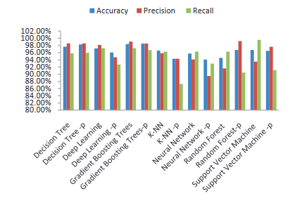
Figure 1: comparison performance after feature selection ((RENJITH, P., 2021))
The effect of sampling (Kumar, M.A., 2022) in the machine learning malware analysis proposed on testing and training the dataset to select the feature on target variable and train the machine learning model and getting the outcome of prediction on app permission dataset of android phone the malware depends on the user permission given by the user and user tend to grant permission unknowingly on such dangerous application to cause the problem over device machine learning random forest classifier , genetic algorithm gradient boost, decision tree and support vector machine classifier produce the great outcome to detect and prevent the malware from the android phone, it is suggested that the latest android phone security updated with avoid of malware attack due to secure application permission access based on the user grant. The precision call and F score present with great accuracy report to identify the malware from android phone by using advance machine learning method.

Chapter # 5 Discussion & Conclusion

Mobile android phone various (Sangal, A.L., 2021) malware detection has been proceed from the machine learning technique, due to increasing popularity of android phone, various developer develop malware on daily basis to destroy the android operating system and applications. This research proposed framework detect mobile malware from the android phone and prevent them and the proposed framework supporting dynamic analysis by performing machine learning strategies, the mobile system able to detect real time android application by scanning various mobile phone applications with the help of android malware detection system of advance machine learning technique, by gaining the feature selection approach it has been addressed to solves the various feature selection problem by training and testing the dataset of android application. Additionally the following feature used to detect the android applications by performing the 500, 000 android apps still the android applications is not secured there is need to improve them. User is protected to installed third party software from other sources, so there is need to facilitate them additionally by supporting various android applications scanning. Empirical results revealed presented various machine learning technique which process parallel machine learning and deep learning algorithm performed the furthest principal gathering technique Y-MLP and nonlinear ensembles decision tree approach by selecting feature selection approach and detect the highest detection rate of 98% to detect and prevent malware from android phone in real world apps. (Mesleh, A., Awajan, A., 2020) intelligent mobile malware detection using permission request and API calls. Malware is serious threats that posing to threat the android phone user badly, two types of android malware attacked on android operating system fraudulent mobile app and injected malicious mobile app. Android mobile phones uses various amount of three dimensional grouping targeting strategies to group the dataset. The valuable mobile API calls to maximize the likelihood to maximize the likelihood to identifying the mobile malware application, since the android malicious applications invoke on different API calls which mobile malware often used to scan the risky apps. Android app using the ambiguous group and risky group to scan the android malware app with various framework scanning feature. (Canfora, G. Cimitile, A., 2016) mobile malware detection in the real world to detect and prevent the real world mobile application by installing the user in real instance various machine learning algorithm has been predicted by various researcher in the past, several feature has been tested and predicted and prevented by the machine learning algorithm. Various researcher addressed mobile malware technique and addressed the solution in the literature, the studies addressed the different mobile malware detection technique, and several problem has been classified mobile malware detection problems by addressing the solution towards the leading goal of machine learning detection classification, K nearest neighbors does not provides the great accuracy due to the hyperplanes was not reflected the target variable on the prediction discovery of mobile malware security permission apps. Various researcher published empirical studies aimed at accessing the quality of set of feature, different researcher addressed proposed the quality behavior of machine learning algorithm and the discriminant a trusted applications by malicious one extracting opcode-based feature since the android application variant open source ended the application is open and accessible across the leading network correspondence. The mobile security feature applications has been classified on different mobile security feature detection, it can be used & classified on starting point to define the classification approach to detect the real time mobile application which has been classified and addressed the solution. the experiment result present the accuracy prediction rate which has been classified and prevented on support vector machine classifier and decision tree with random forest classifier method. (Sahs, J. Khan, L., 2012) machine learning based approach has been deployed previously on the classification of mobile malware detection. The recent emergence of mobile platform which capable of executing the increasing complex solution of software solutions has been suggested and organized the sensitive applications such as banking applications associated with the malware targeted application at mobile device. The problem has been detected and classified due to limited resource available and limited privileges granted to the user the studies preset the unique idea of machine learning detection discovery which has been analyzed in the past since the application contains adware advertisement and backdoor advertisement which cause problematic situation on the android device since the various third party mobile applications was not reflected due to instability of various mobile applications the machine learning based approach has been used in the past which proposed on unique property of required meta data and scan the real application of android phone since the mobile applications was not secured due to the instability of other applications. The problem has been detected and identified on various mobile permission dataset which does not reflect the applications due to the limited resources available on privileges granted to the user the information has been passed out and prevented which based on the application scanning the target application which was attached on each application by using the Meta data application. Since the android phone application connected with backend Google API based on Meta data information searching information. The research has been presented the various state of the art machine learning method based system which discovered the android app permission access, the previous android release contains various issues and problem which extract the various malware information contains the different attribute of dataset. The application has been monitored and prevented on the discovery of android malware detection & prevention since the machine learning based system for the detection of malware detection discovery which based on malware on android device. The proposed system based on extract the number of feature by training and testing the dataset, because the training and testing feature extract the target applications on the basis of different set of attributes which related to the attribute classification techniques has been monitored and classified on advance machine learning classification techniques. Since the offline classification method proposed on support vector classification technique which was classified on number of feature selection based approach. (Lin, H. Liu, Y., 2020) experiencing of machine learning onto the market scale mobile malware detection.

Comparison
Since the application is stable due to the latest release of android operating system which contains the different feature classification method. Mobile eco system has become the natural classification method proposed on machine learning classification malware detection prevention channel has been actually classified & prevented on different mobile attributes classification. It is suggested that the Google updates on update of security feature has been proposed on different classification technique of mobile classification method which has been proposed on the basis of mobile android machine learning based method proposed on classification technique.

Research Achievement

5.1 Research Invention
This research finding presented and suggested the android application contains various malware and contain with virus information. Since the research finding present the android permission application based dataset which has been analyzed and predicted on research method. This research fill the gap in between the mobile releases and latest version of android operating system, because stable release of android operating system has been analyzed on different parameter of malware detection & prevention discovery. The bogus advertisements presented on insecure website which has been access by the android operating system and monitored on different parameter. Google platform is much secure and providing Google API layers functionality to the android user which extracted the useful information without any hurdles and malware. Various banking applications is secured and stable which proposed their own private network which classified and administered on different parameter of mobile malware detection and prevention based discovery. It is suggested and presented through the research finding the machine learning method has been used by the Google to protect the android operating system from the outside malware and third party illegal software discovery. The better understanding of machine learning discovery which proposed on various machine learning based method proposed & analyzed on different scales of machine learning algorithm discovery. Mobile malware detection has been classified & administered on different parameter of various mobile method technique since the modern and advance machine learning algorithm discovered the various features of malware detection & prevention.

5.2 Mobile Malware Discovery

Android phone was not performing well in the previous releases of android phone, due to insecure and instable android operating system since the upgradation appear in 2017 and 2018 year, Google planned to update the android phone security features followed by the third party API layers of Google service layer. Google in these days much secured operating system for the android family and so the question of malware is now out of question due to the reliability exists in 2021, this research finding and discovery present that the android phone is stable and reliable in year 2021 because of reliable applications installation parameter based on user permission choice. It is suggested that the Google built in machine learning feature are updated and processed on different parameter. Google operating system are updated and revised the security feature which are much reliable and needful. Android 11 version are more stable and reliable because of application permission installation performed on user permission if the user allow to add the new app based on the user selection and user choice it is recommended and otherwise the application is not add in android phone. Since the previous android version contains various malware attack attribute which was connected in real time web application portal and interact the virus to installed the software automatically in the android phone and some application in android phone are automatically remove after some period of time due to the malware attack happened in before 2017 these types of issues appear commonly in the android phone. Software are installed automatically and software are removed automatically in previous android releases now the issue has been resolved and updated, this research review the basic research gap from 2011 to 2017 in literature review section and after update of android operating system release which is considered much reliable operating system because 86% market share of android phone due to its popularity. Since the mobile malware attacked happened on adware based, backdoor and ransomeware attack happened on android phone but these issues resolved by using the machine learning algorithm discovery parameter detecting the malicious app and malicious malware from the android operating system.

5.3 Research Outcome

Since the mobile T-market evaluated and discussed on different mobile communication channels (Vakalis, I., 2018) dynamic permission based android malware detection technique using machine learning method the android based application contains malware and different insecure advertisements which cause problematic situation the android phone not secured in previous mobile version because of low security feature and low API interface of over the android phone. Android application needs the number of sensitive permission during their installation and runtime. Various android running and execution application required user permission to execute and retrieve them on real time internet interface. The contribution of this research based on android permission dataset of APK file and other mobile android dataset which proposed the solution by scanning the different features and parameter of android phone and discovered and suggest the solution to protect the third party application from unknown user. This research evaluate the number of parameter of dataset by selecting the feature selection and selecting the parameter of training and testing the dataset to predict and validate the dataset the 123 dynamic permission based security feature solved the execution level of API layer functionality to predict and prevent the malware from the android phone. Since the machine learning classifier method predict on various algorithm based strategies such as naïve bays classifier and support vector machine classifier and decision tree classifier method proposed to predict the android permission dataset, since the model tuning and training to predict the Relu functionality of machine learning algorithm which founded on the parameter of classification techniques. The experiment result present that the malware classification prediction accuracy proposed on RF, J48 and SL are comparable the performance of marginal techniques has been actively analyzed based on the training the dataset feature. (Zhao, Y., Li, L., Wang. 2021) the impact of sample duplication in machine learning method discovery proposed on the parameter classification of android malware detection and removal method, android operating system is stable and accurate because of various operating system secured API layer functionality protect the mobile application from unknown access the duplication of attribute changing which needs to change the parameter of mobile and APK attribute, so there is need to fix the attribute parameter of APK which would be secured techniques to secure the app from the malware attack. The experiment result show the sample space of malware detection, the duplication of application installation with minor changing of attribute which cause problem on android phone due to non-secure installation featured on different classification technique parameter which reflect the base of malware attack. The distribution of third party layer functionality which proposed on designing the app which are not reliable. So it is concluded that Google updated their security features, in android 11 and 12 operating system versions, now this research says that android phone is much secure.

6.References

Gong, L., Li, Z., Qian, F., Zhang, Z., Chen, Q.A., Qian, Z., Lin, H. and Liu, Y., 2020, April. Experiences of landing machine learning onto market-scale mobile malware detection. In Proceedings of the Fifteenth European Conference on Computer Systems (pp. 1-14).

Wei, S., Zhang, Z., Li, S. and Jiang, P., 2021. Calibrating Network Traffic with One-Dimensional Convolutional Neural Network with Autoencoder and Independent Recurrent Neural Network for Mobile Malware Detection. Security and Communication Networks, 2021.

Omer, M.A., Zeebaree, S.R., Sadeeq, M.A., Salim, B.W., x Mohsin, S., Rashid, Z.N. and Haji, L.M., 2021. Efficiency of malware detection in android system: A survey. Asian Journal of Research in Computer Science, pp.59-69.
Casolare, R., De Dominicis, C., Iadarola, G., Martinelli, F., Mercaldo, F. and Santone, A., 2021. Dynamic Mobile Malware Detection through System Call-based Image representation. J. Wirel. Mob. Networks Ubiquitous Comput. Dependable Appl., 12(1), pp.44-63.
Kouliaridis, V., Barmpatsalou, K., Kambourakis, G. and Chen, S., 2020.A survey on mobile malware detection techniques. IEICE Transactions on Information and Systems, 103(2), pp.204-211.
M. Z. Mas'ud, S. Sahib, M. F. Abdollah, S. R. Selamat and R. Yusof, "Analysis of Features Selection and Machine Learning Classifier in Android Malware Detection," 2014 International Conference on Information Science & Applications (ICISA), 2014

Chen, Z., Yan, Q., Han, H., Wang, S., Peng, L., Wang, L. and Yang, B., 2018. Machine learning based mobile malware detection using highly imbalanced network traffic. Information Sciences, 433, pp.346-364.

Ham, H.S. and Choi, M.J., 2013, October. Analysis of android malware detection performance using machine learning classifiers. In 2013 international conference on ICT Convergence (ICTC) (pp. 490-495). Ieee.

Amos, B., Turner, H. and White, J., 2013, July. Applying machine learning classifiers to dynamic android malware detection at scale. In 2013 9th international wireless communications and mobile computing conference (IWCMC) (pp. 1666-1671). IEEE.

Martinelli, F., Mercaldo, F., Nardone, V., Santone, A. and Vaglini, G., 2020. Model checking and machine learning techniques for HummingBad mobile malware detection and mitigation. Simulation Modelling Practice and Theory, 105, p.102169.

M. Al-Janabi and A. M. Altamimi, "A Comparative Analysis of Machine Learning Techniques for Classification and Detection of Malware," 2020 21st International Arab Conference on Information Technology (ACIT), 2020, pp. 1-9,

Uppin, C., & George, G. Analysis of Android Malware Using Data Replication Features Extracted by Machine Learning Tools. International Journal of Scientific Research in Computer Science, Engineering and Information Technology, 193–201. 2019

Baldini, G. and Geneiatakis, D., 2019, April. A performance evaluation on distance measures in KNN for mobile malware detection. In 2019 6th international conference on control, decision and information technologies (CoDIT) (pp. 193-198). IEEE.

Shahpasand, M., Hamey, L., Vatsalan, D. and Xue, M., 2019, February. Adversarial attacks on mobile malware detection. In 2019 IEEE 1st International Workshop on Artificial Intelligence for Mobile (AI4Mobile) (pp. 17-20). IEEE.

Agrawal, P. and Trivedi, B., 2021. Machine learning classifiers for android malware detection. In Data Management, Analytics and Innovation (pp. 311-322). Springer, Singapore.

Anuar, N.A., Mas’ud, M.Z., Bahaman, N. and Ariff, N.A.M., 2020, November. Analysis of machine learning classifier in Android malware detection through opcode. In 2020 IEEE Conference on Application, Information and Network Security (AINS) (pp. 7-11). IEEE.

Charbuty, B. and Abdulazeez, A., 2021. Classification based on decision tree algorithm for machine learning. Journal of Applied Science and Technology Trends, 2(01), pp.20-28.
Wang, P., Fan, E. and Wang, P., 2021. Comparative analysis of image classification algorithms based on traditional machine learning and deep learning. Pattern Recognition Letters, 141, pp.61-67.

Kasinathan, T., Singaraju, D. and Uyyala, S.R., 2021. Insect classification and detection in field crops using modern machine learning techniques. Information Processing in Agriculture, 8(3), pp.446-457.

Abdulkareem, N.M. and Abdulazeez, A.M., 2021. Machine learning classification based on Radom Forest Algorithm: A review. International Journal of Science and Business, 5(2), pp.128-142.
Hani, S.I. and Sahib, N.M., 2021. Mobile Malware Detection using Anomaly Based Machine Learning Classifier Techniques. Diyala Journal For Pure Science, 17(02).
Narudin, F.A., Feizollah, A., Anuar, N.B. et al. Evaluation of machine learning classifiers for mobile malware detection. Soft Comput 20, 343–357 (2016). https://doi.org/10.1007/s00500-014-1511-6
Gong, L., Li, Z., Qian, F., Zhang, Z., Chen, Q.A., Qian, Z., Lin, H. and Liu, Y., 2020, April. Experiences of landing machine learning onto market-scale mobile malware detection. In Proceedings of the Fifteenth European Conference on Computer Systems (pp. 1-14).
Arif, J.M., Ab Razak, M.F., Mat, S.R.T., Awang, S., Ismail, N.S.N. and . Android mobile malware detection using fuzzy AHP. Journal of Information Security and Applications, 61, p.102929.

Iadarola, G., Martinelli, F., Mercaldo, F. and Santone, A., 2021. Towards an interpretable deep learning model for mobile malware detection and family identification. Computers & Security, 105, p.102198.

Kouliaridis, V. and Kambourakis, G., 2021. A Comprehensive Survey on Machine Learning Techniques for Android Malware Detection. Information, 12(5), p.185.
Mahindru, A. and Sangal, A.L., 2021. MLDroid—framework for Android malware detection
using machine learning techniques. Neural Computing and Applications, 33(10), pp.5183-5240.

Mercaldo, F. and Santone, A., 2021. Formal Equivalence Checking for Mobile Malware Detection and Family Classification. IEEE Transactions on Software Engineering.

Wei, S., Zhang, Z., Li, S. and Jiang, P., 2021. Calibrating Network Traffic with One-Dimensional Convolutional Neural Network with Autoencoder and Independent Recurrent Neural Network for Mobile Malware Detection. Security and Communication Networks, 2021.

Omer, M.A., Zeebaree, S.R., Sadeeq, M.A., Salim, B.W., x Mohsin, S., Rashid, Z.N. and Haji, L.M., 2021. Efficiency of malware detection in android system: A survey. Asian Journal of Research in Computer Science, pp.59-69.
Casolare, R., De Dominicis, C., Iadarola, G., Martinelli, F., Mercaldo, F. and Santone, A., 2021. Dynamic Mobile Malware Detection through System Call-based Image representation. J. Wirel. Mob. Networks Ubiquitous Comput. Dependable Appl., 12(1), pp.44-63.
Kouliaridis, V., Barmpatsalou, K., Kambourakis, G. and Chen, S., 2020.A survey on mobile malware detection techniques. IEICE Transactions on Information and Systems, 103(2), pp.204-211.

Raghuraman, C., Suresh, S., Shivshankar, S. and Chapaneri, R., 2020. Static and dynamic malware analysis using machine learning. In First International Conference on Sustainable Technologies for Computational Intelligence (pp. 793-806). Springer, Singapore.

Abdullah, T.A., Ali, W. and Abdulghafor, R., 2020. Empirical study on intelligent Android malware detection based on supervised machine learning. Int. J. Adv. Comput. Sci. Appl.(IJACSA), 11(4).

Rana, M.S., Gudla, C. and Sung, A.H., 2018, December. Evaluating machine learning models for Android malware detection: A comparison study. In Proceedings of the 2018 VII International Conference on Network, Communication and Computing (pp. 17-21).

Kuruvila, A.P., Kundu, S. and Basu, K., 2020, July. Analyzing the efficiency of machine learning classifiers in hardware-based malware detectors. In 2020 IEEE Computer Society Annual Symposium on VLSI (ISVLSI) (pp. 452-457). IEEE.

Gyunka, B.A., Abikoye, O.C. and Adekunle, A.S., 2020, November. Anomaly Android Malware Detection: A Comparative Analysis of Six Classifiers. In International Conference on Information and Communication Technology and Applications (pp. 145-157). Springer, Cham.

Osman, M.Z., Abidin, A.F.Z., Romli, R.N. and Darmawan, M.F., 2021, August. Pixel-based Feature for Android Malware Family Classification using Machine Learning Algorithms. In 2021 International Conference on Software Engineering & Computer Systems and 4th International Conference on Computational Science and Information Management (ICSECS-ICOCSIM) (pp. 552-555). IEEE.

Anshori, M., Mar'i, F. and Bachtiar, F.A., 2019, September. Comparison of machine learning methods for android malicious software classification based on system call. In 2019 International Conference on Sustainable Information Engineering and Technology (SIET) (pp. 343-348). IEEE.

https://www.kaggle.com/vishnu0399/android-malware

https://github.com/rozer821/Android_Malware_classifier

https://github.com/anoopmsivadas/android-malware-detection
Al Ali, M., Svetinovic, D., Aung, Z. and Lukman, S., 2017, December. Malware detection in android mobile platform using machine learning algorithms. In 2017 International Conference on Infocom Technologies and Unmanned Systems (Trends and Future Directions)(ICTUS) (pp. 763-768). IEEE.

Rana, M.S., Gudla, C. and Sung, A.H., 2018, December. Evaluating machine learning models for Android malware detection: A comparison study. In Proceedings of the 2018 VII International Conference on Network, Communication and Computing (pp. 17-21).

Zou, S., Zhang, J. and Lin, X., 2015. An effective behavior‐based Android malware detection system. Security and Communication Networks, 8(12), pp.2079-2089.

Sangal, A. and Verma, H.K., 2020, September. A static feature selection-based android malware detection using machine learning techniques. In 2020 International conference on smart electronics and communication (ICOSEC) (pp. 48-51). IEEE.

Yildiz, O. and Doğru, I.A., 2019. Permission-based android malware detection system using feature selection with genetic algorithm. International Journal of Software Engineering and Knowledge Engineering, 29(02), pp.245-262.

Zhu, H.J., Jiang, T.H., Ma, B., You, Z.H., Shi, W.L. and Cheng, L., 2018. HEMD: a highly efficient random forest-based malware detection framework for Android. Neural Computing and Applications, 30(11), pp.3353-3361.

Singh, L. and Hofmann, M., 2017, December. Dynamic behavior analysis of android applications for malware detection. In 2017 International Conference on Intelligent Communication and Computational Techniques (ICCT) (pp. 1-7). IEEE.

Ali, W., 2019. Hybrid intelligent android malware detection using evolving support vector machine based on genetic algorithm and particle swarm optimization. IJCSNS, 19(9), p.15.

Osman, M.Z., Abidin, A.F.Z., Romli, R.N. and Darmawan, M.F., 2021, August. Pixel-based Feature for Android Malware Family Classification using Machine Learning Algorithms. In 2021 International Conference on Software Engineering & Computer Systems and 4th International Conference on Computational Science and Information Management (ICSECS-ICOCSIM) (pp. 552-555). IEEE.

Ganapathi, P., Shanmugapriya, D. and Roshni, A., 2022. Dynamic Analysis Based Mobile Malware Classification Using Supervised Machine Learning Methods. Dynamic Analysis Based Mobile Malware Classification Using Supervised Machine Learning Methods, pp.1-168.

Anidu, A. and Obuzor, Z., 2022. Evaluation of machine learning algorithms on Internet of Things (IoT) malware opcodes. In Handbook of Big Data Analytics and Forensics (pp. 177-191). Springer, Cham.

Saleem, M.S., Mišić, J. and Mišić, V.B., 2022. Android Malware Detection using Feature Ranking of Permissions. arXiv preprint arXiv:2201.08468.

CHANDRIKA, A.T.B., VIJAYANAND, R. and RAO, D.P.S., ANDROID MALWARE DETECTION USING EXTRA TREES CLASSIFIER BASED FEATURE SELECTION AND MACHINE LEARNING. 2021

RAMESH, K., BENNET, M.A., VEERAPPAN, J. and RENJITH, P., 2021, April. Performance Metric System for Malicious URL Data using Revised Random Forest Algorithm. In 2021 5th International Conference on Computing Methodologies and Communication (ICCMC) (pp. 1188-1191). IEEE.

Thimmaiah, K.S., Raj, L.S., Bolimera, P. and Kumar, M.A., 2022. The Effect of Sampling in the Machine Learning-Based Malware Analysis. In Proceedings of International Conference on Intelligent Cyber-Physical Systems (pp. 143-156). Springer, Singapore.

Mahindru, A. and Sangal, A.L., 2021. MLDroid—framework for Android malware detection using machine learning techniques. Neural Computing and Applications, 33(10), pp.5183-5240.

Alazab, M., Alazab, M., Shalaginov, A., Mesleh, A. and Awajan, A., 2020. Intelligent mobile malware detection using permission requests and API calls. Future Generation Computer Systems, 107, pp.509-521.

Mercaldo, F., Visaggio, C.A., Canfora, G. and Cimitile, A., 2016, May. Mobile malware detection in the real world. In 2016 IEEE/ACM 38th International Conference on Software Engineering Companion (ICSE-C) (pp. 744-746). IEEE.

Sahs, J. and Khan, L., 2012, August. A machine learning approach to android malware detection. In 2012 European Intelligence and Security Informatics Conference (pp. 141-147). IEEE.

Gong, L., Li, Z., Qian, F., Zhang, Z., Chen, Q.A., Qian, Z., Lin, H. and Liu, Y., 2020, April. Experiences of landing machine learning onto market-scale mobile malware detection. In Proceedings of the Fifteenth European Conference on Computer Systems (pp. 1-14).

Geneiatakis, D., Baldini, G., Fovino, I.N. and Vakalis, I., 2018, February. Towards a mobile malware detection framework with the support of machine learning. In International ISCIS Security Workshop (pp. 119-129). Springer, Cham.

Zhao, Y., Li, L., Wang, H., Cai, H., Bissyandé, T.F., Klein, J. and Grundy, J., 2021. On the impact of sample duplication in machine-learning-based android malware detection. ACM Transactions on Software Engineering and Methodology (TOSEM), 30(3), pp.1-38.

Appendices

About the APP on Google Play store

About this app present the application detail which is presented currently in Google play store this method is very useful to identify the app from malware and security prevention. Such as the detail of Netflix app presented in Google play store with great description “Netflix is the leading subscription service for watching TV episodes and movies on internet in real time” this elaboration is very useful before installing this app in android phone. Various android based LED TV does not detect malware due to poor quality of operating system interface and previous versions of android is part of android TV. Since the Google is providing the security to the android phone user which is remarkable discovery of the internet.

Ratings & Reviews on Google Play store

Rating & reviews presented on Google play store which is very useful for the determination and prediction of android application. Review based on 3 star 2 star and 5 star this application rating is very helpful before installing the android app on the android phone. Since in windows operating system Avast, AVIRA, AVG is well recognized virus name it’s not antivirus. Microsoft updated the security features in new release operating system which was introduced in 2015 with the name of windows 10 operating system which contains built in anti-virus, so there is no need to install the third party anti-virus software, since the anti-virus software itself is virus.

Editor Choice APP

Editor choice app presented on Google play store which is secured application suggested by the reliable authoritative members of developer which does not contain virus. Google suggested that the rotating selection of the best apps, which handpicked by the play store editor. Editor choice app functionality works on machine learning prediction based on user choice of interest application interest so the editor choice app automatically generate the suggestion list based on machine learning programming prediction which already secured from malware attack.

